**THE HONG KONG POLYTECHNIC UNIVERSITY**

**Department of Electronic and Information Engineering**

**EIE4108: Distributed Systems and Cloud Computing**

**Lab 2: Cloud Computing using AWS**

**Lab Report**

**Name: Sze Kin Sang**

**Student ID: 19062606D**

**Section 1: Introduction to AWS IAM**

Lab report #1.1:

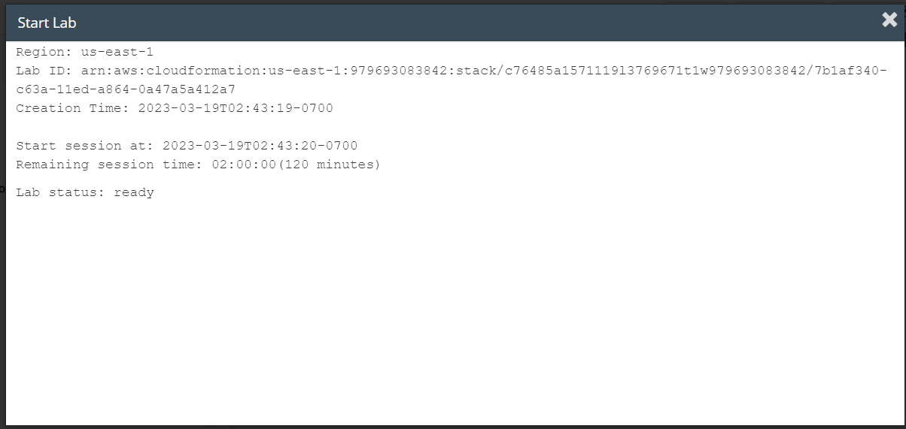

Lab report #1.2:

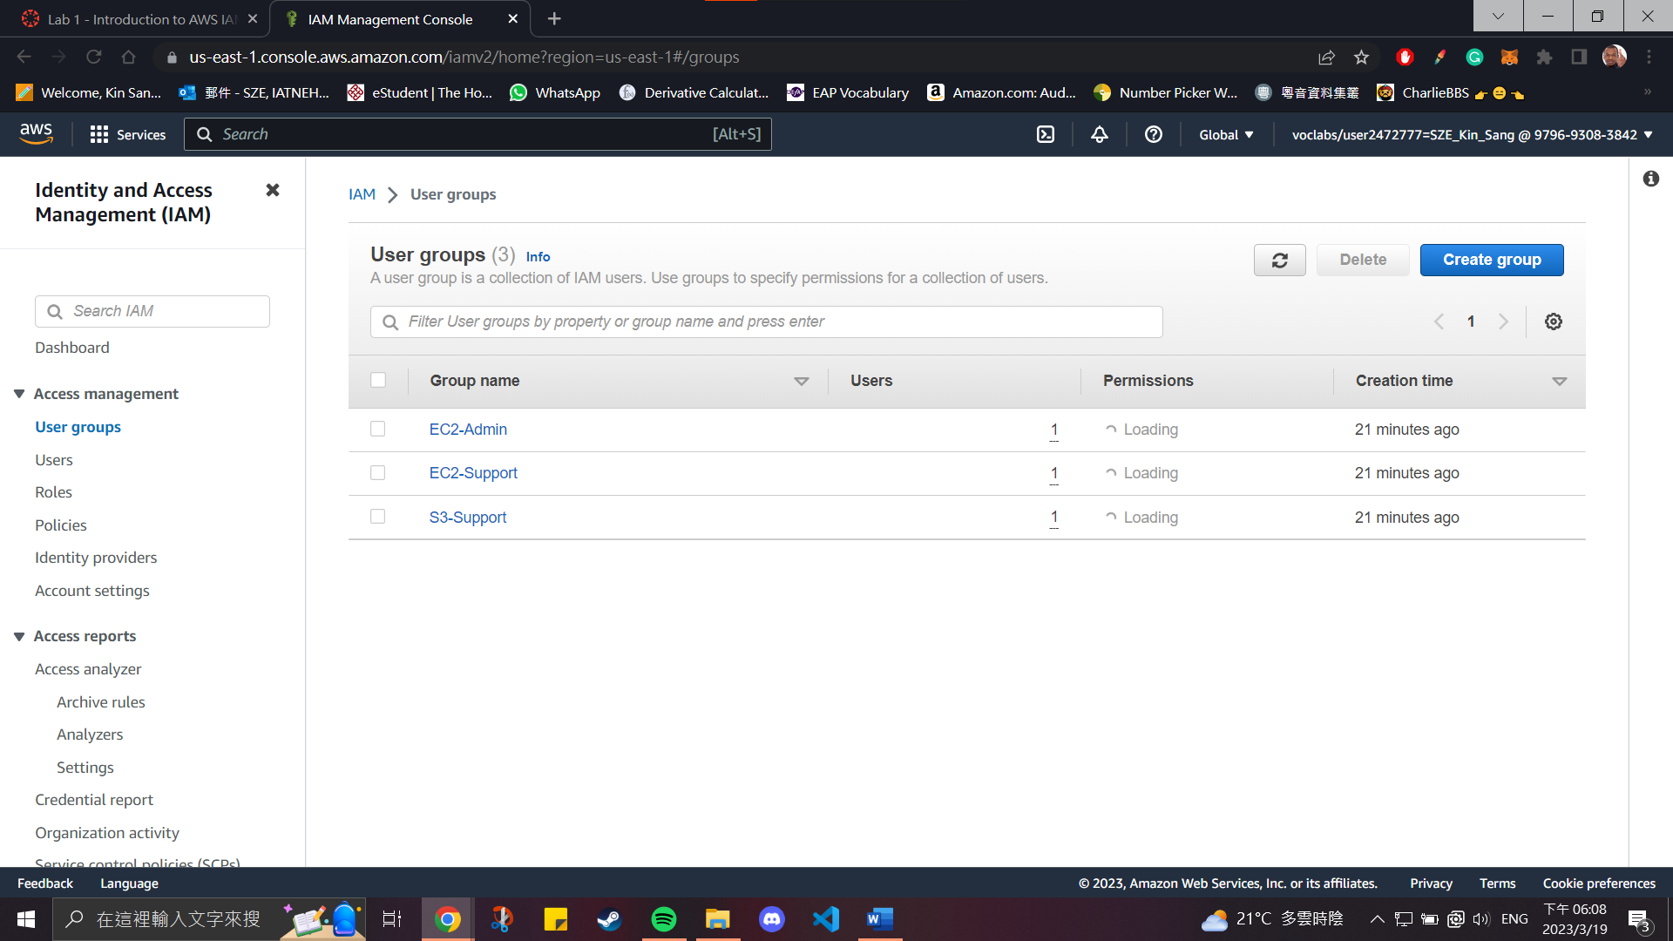

Lab report #1.3:

**IAM users sign-in link:** https://979693083842.signin.aws.amazon.com/console

Lab report #1.4:

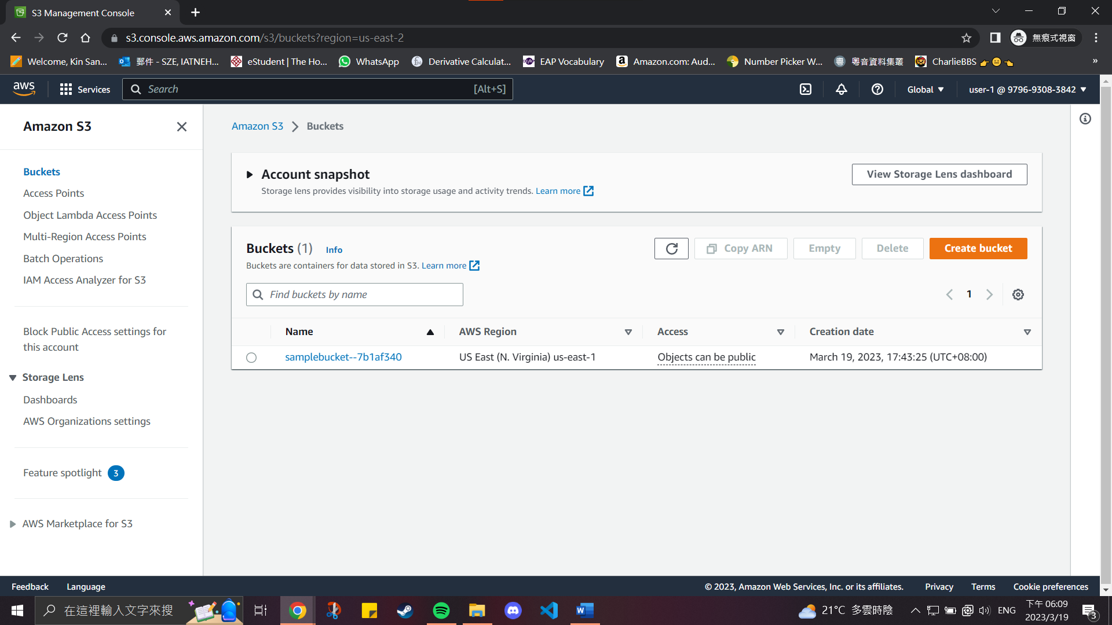

Lab report #1.5:

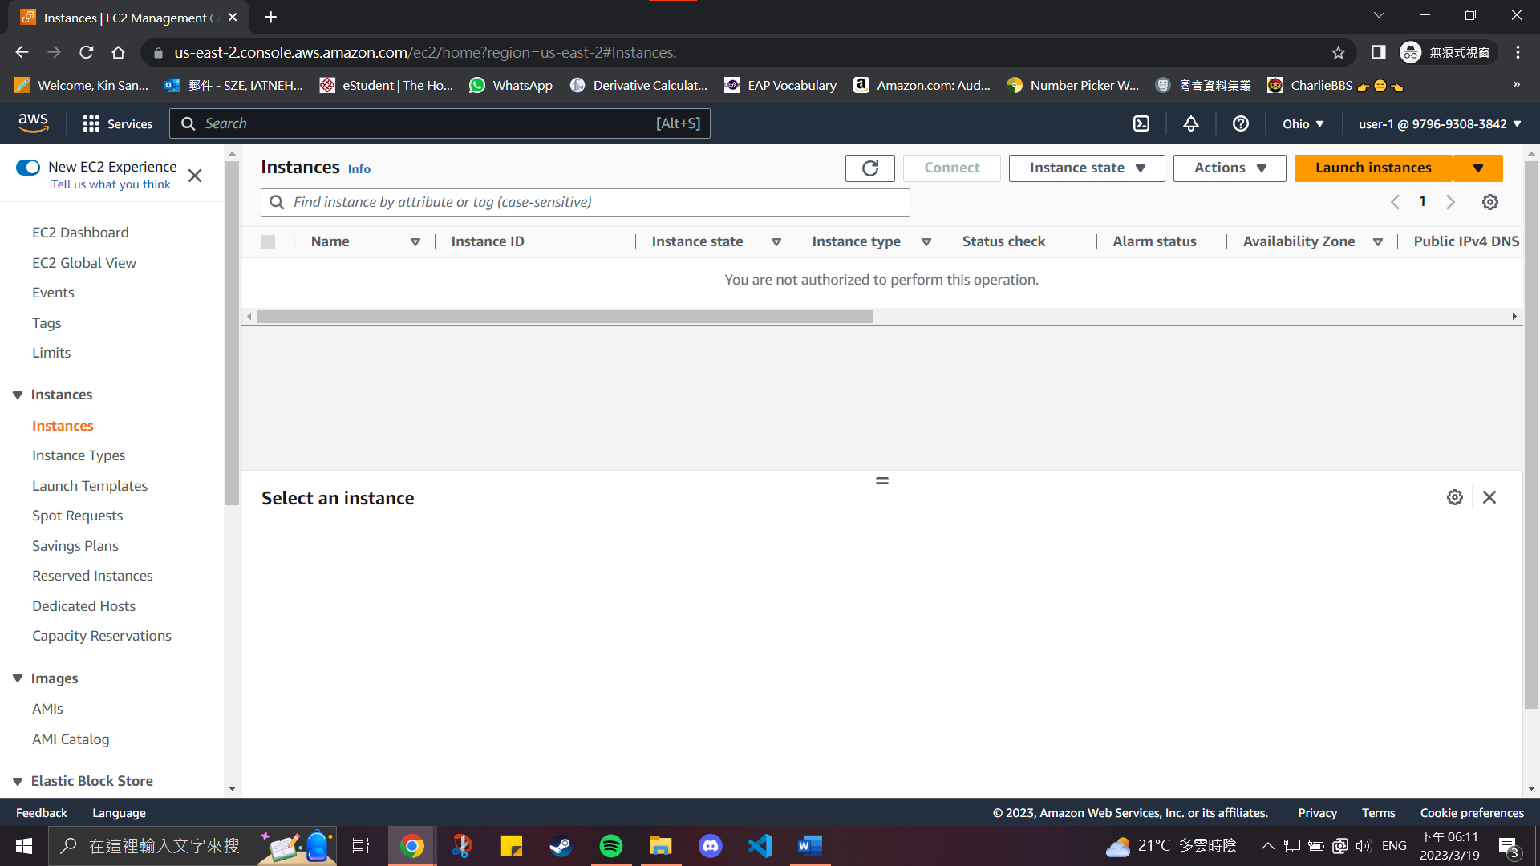

Lab report #1.6:

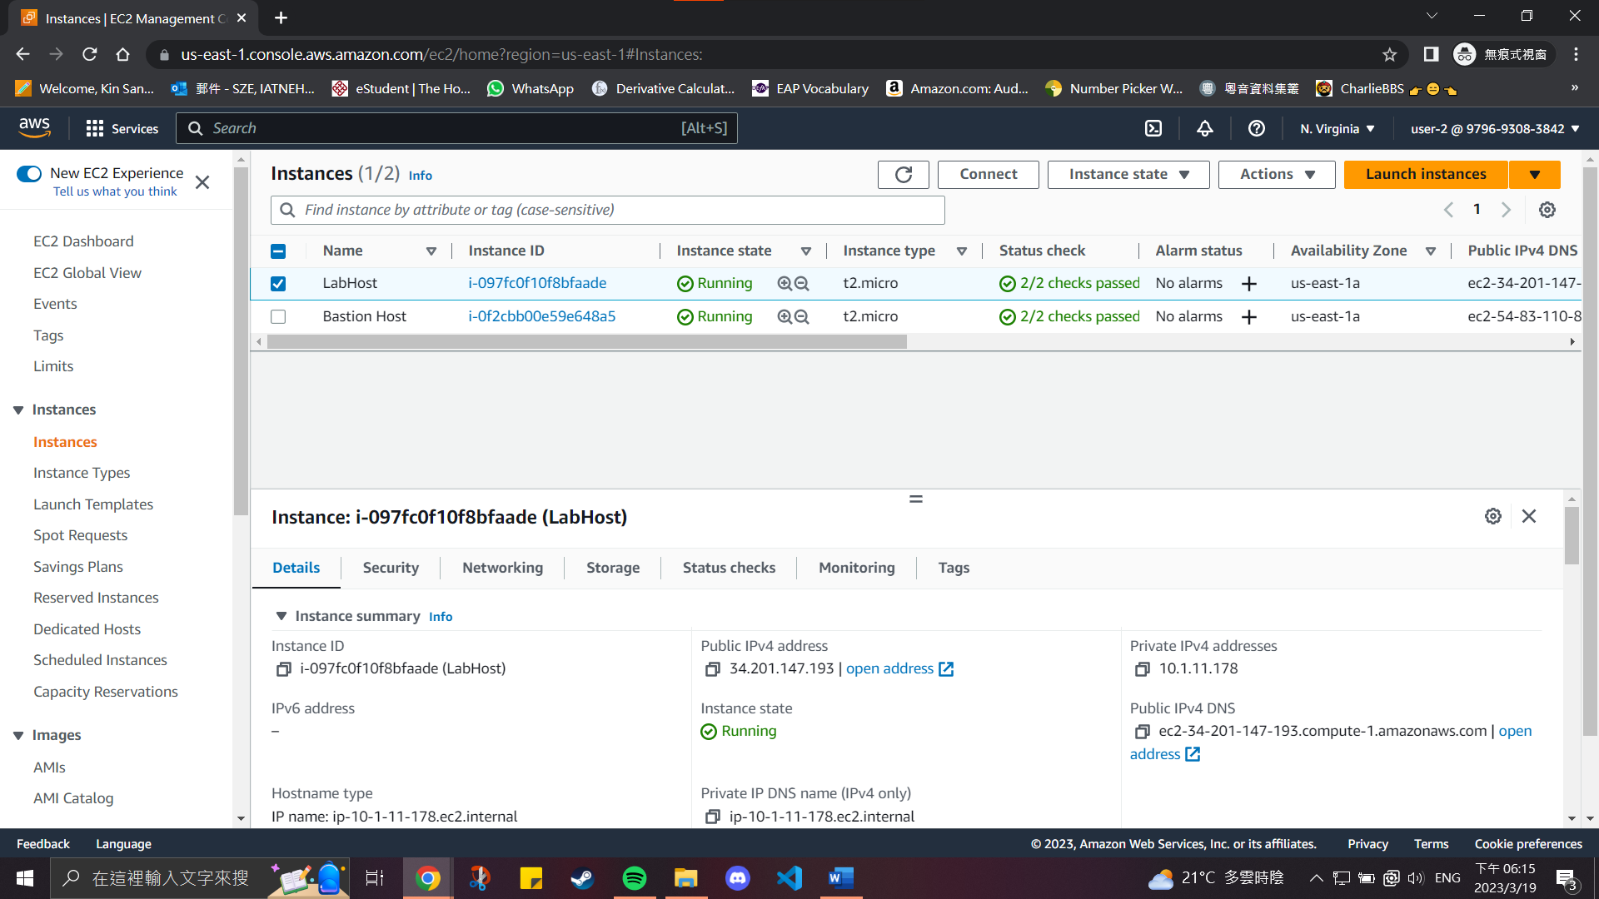

Lab report #1.7:

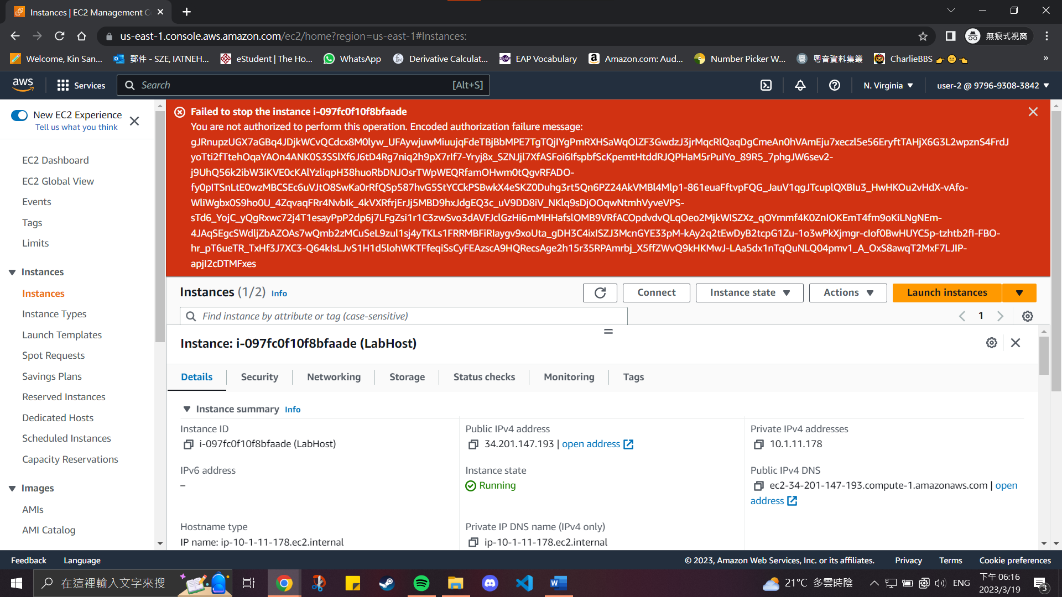

Lab report #1.8:

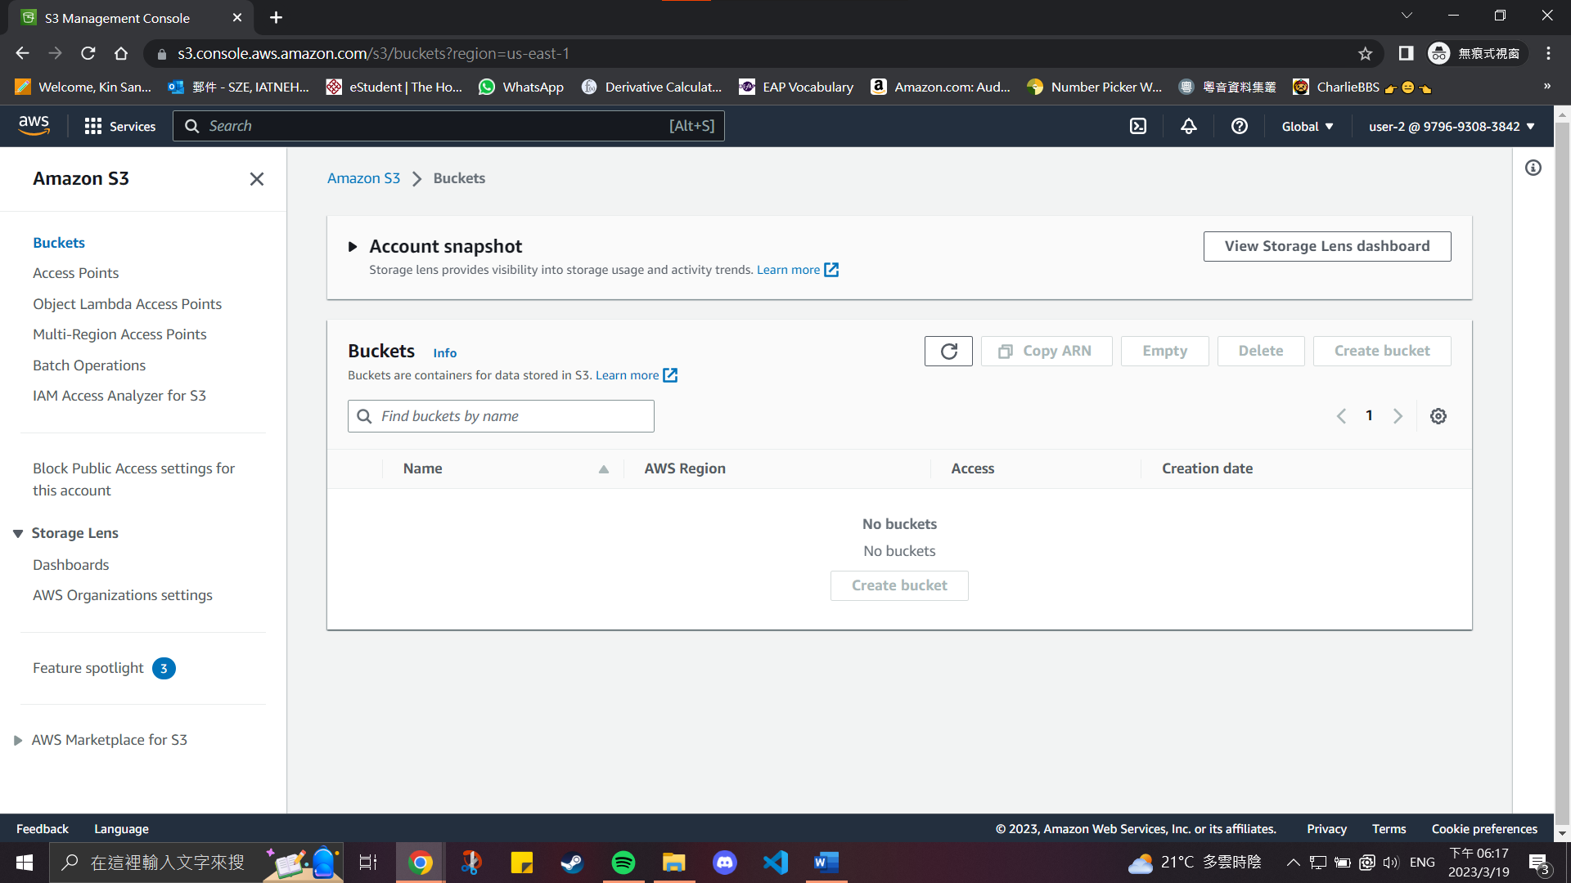

Lab report #1.9:

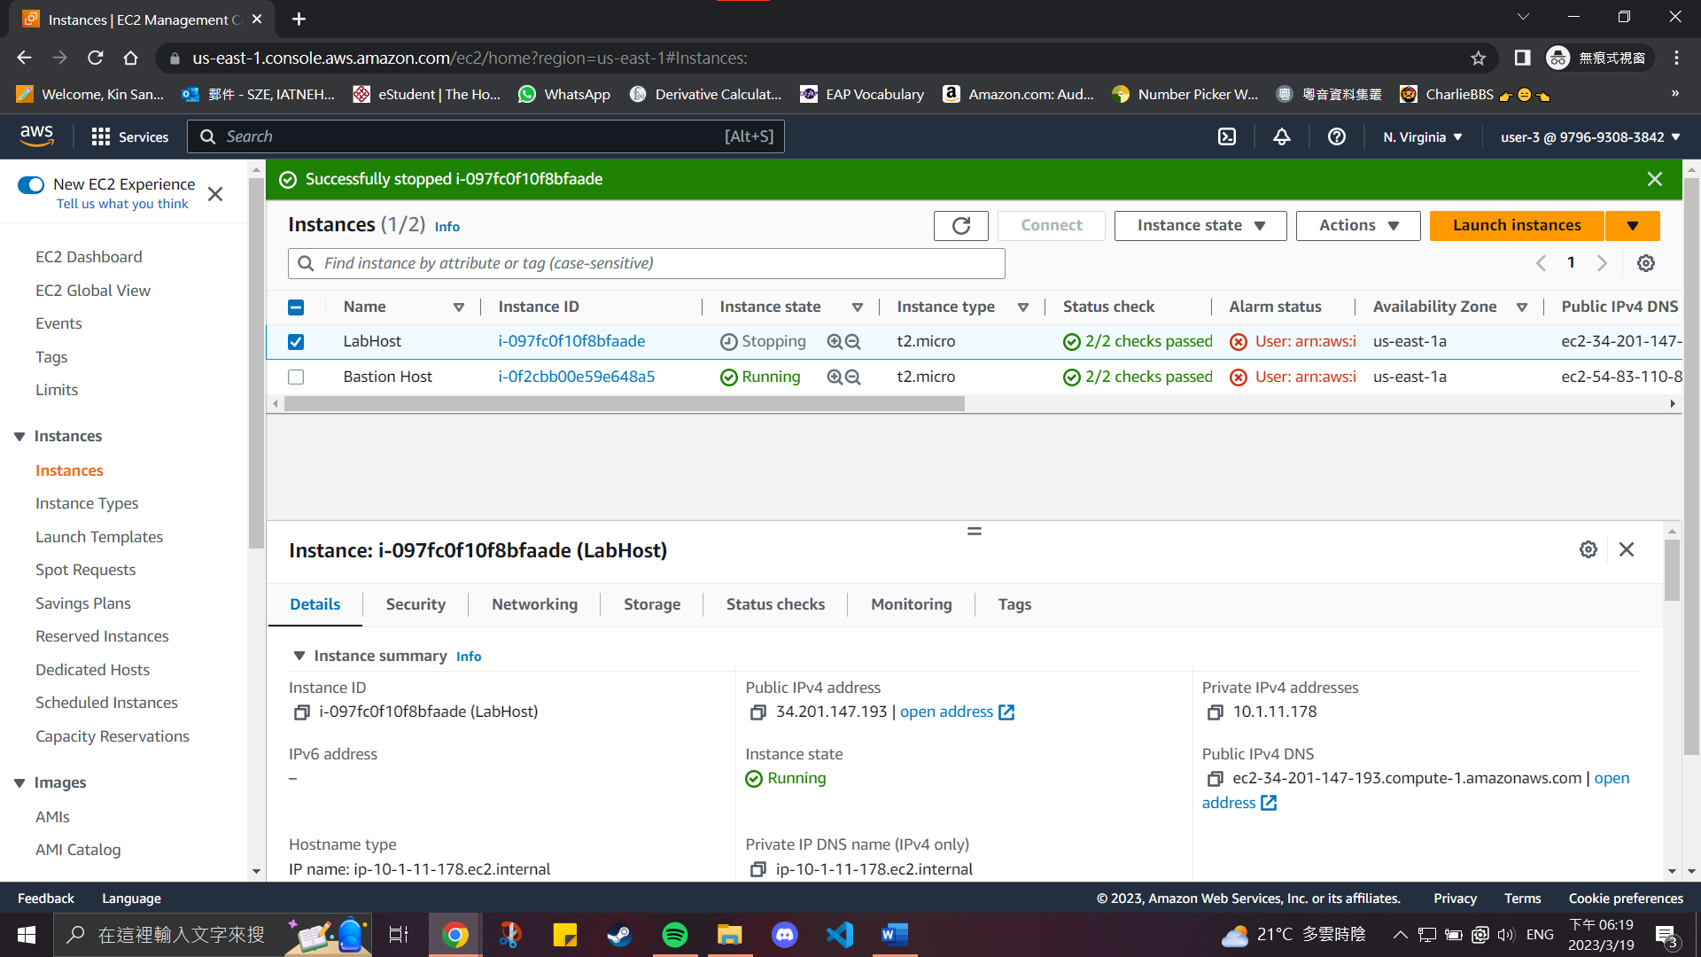

**Section 2: Build your VPC and Launch a Web Server**

Lab report #2.1:

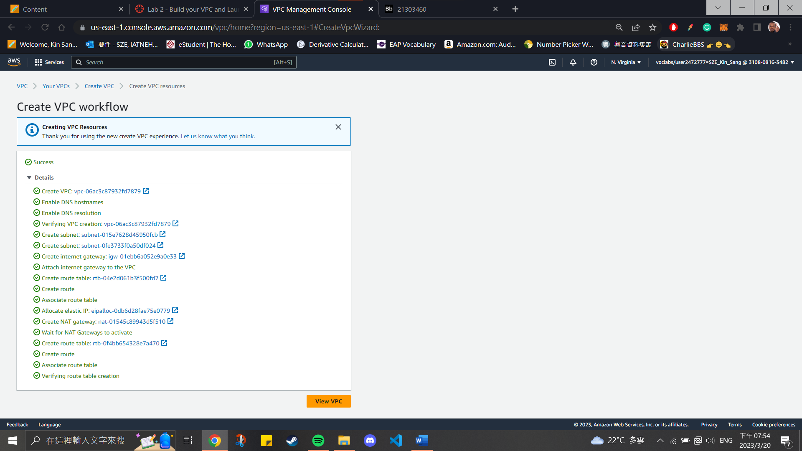

Lab report #2.2:

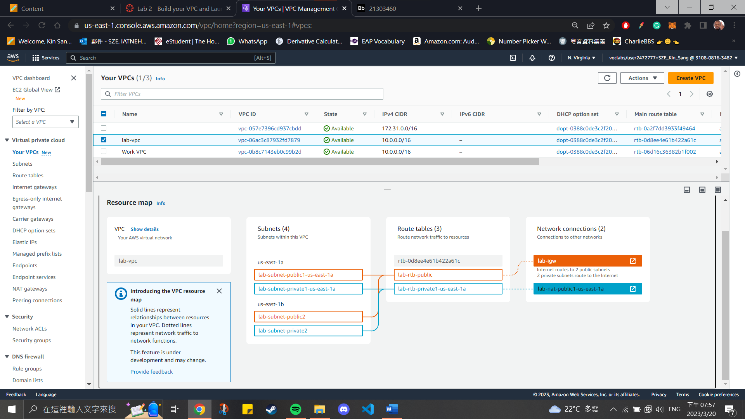

Lab report #2.2:

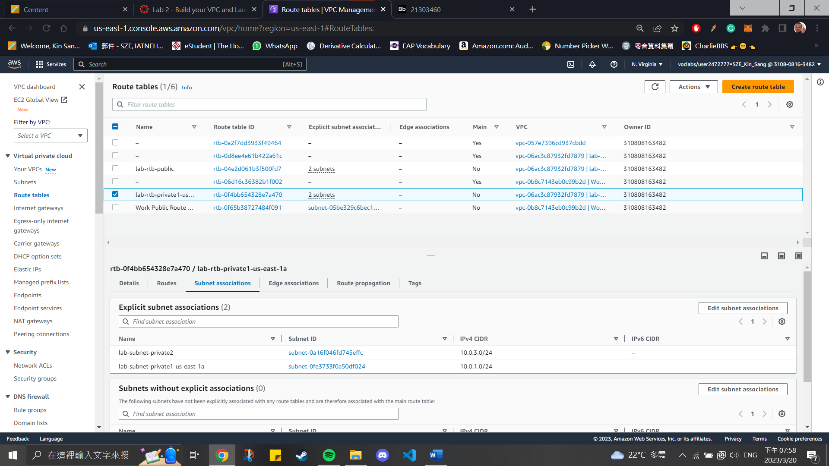

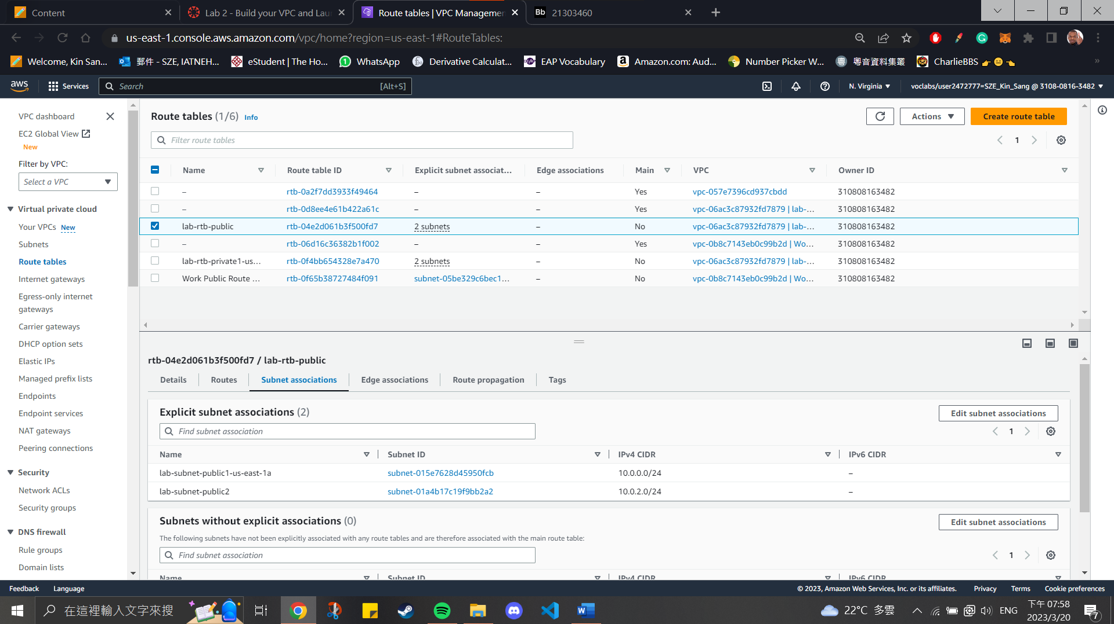

Lab report #2.3:

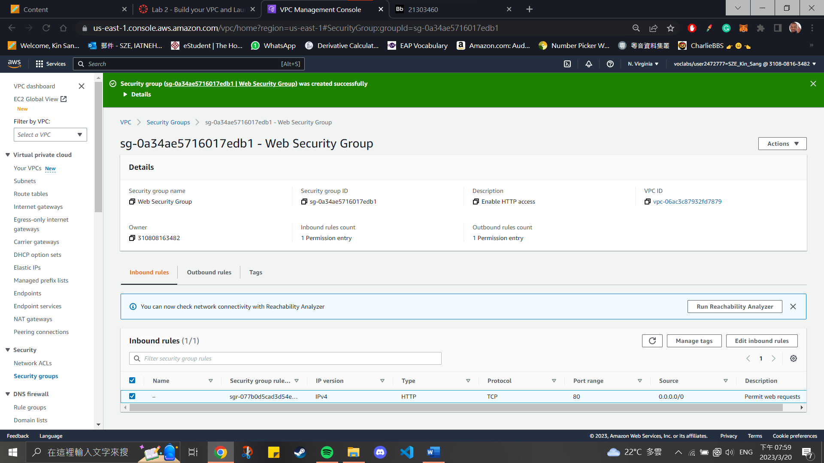

Lab report #2.4:

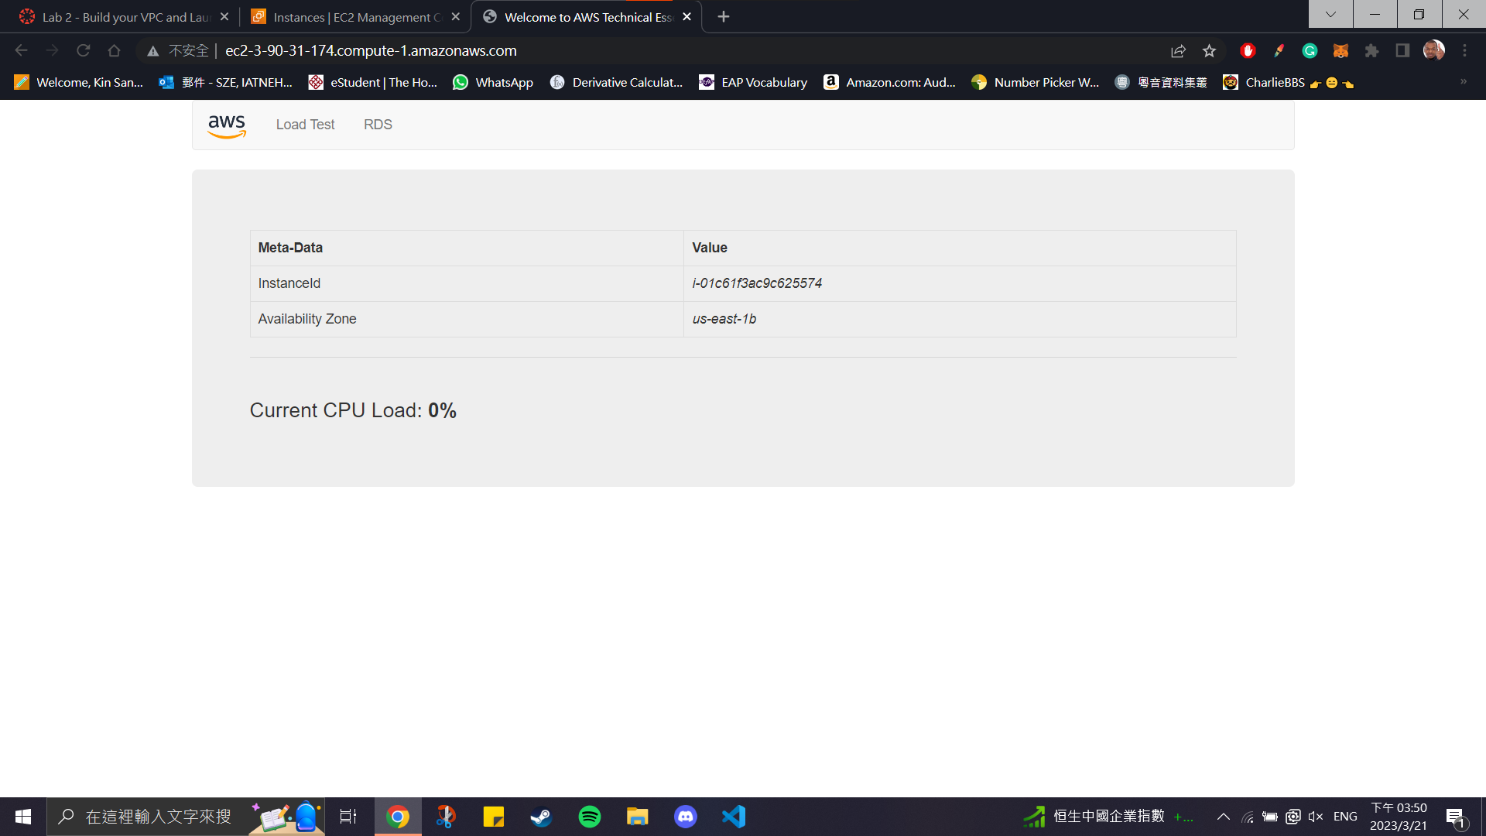

**Section 3: Introduction to Amazon EC2**

Lab report #3.1:

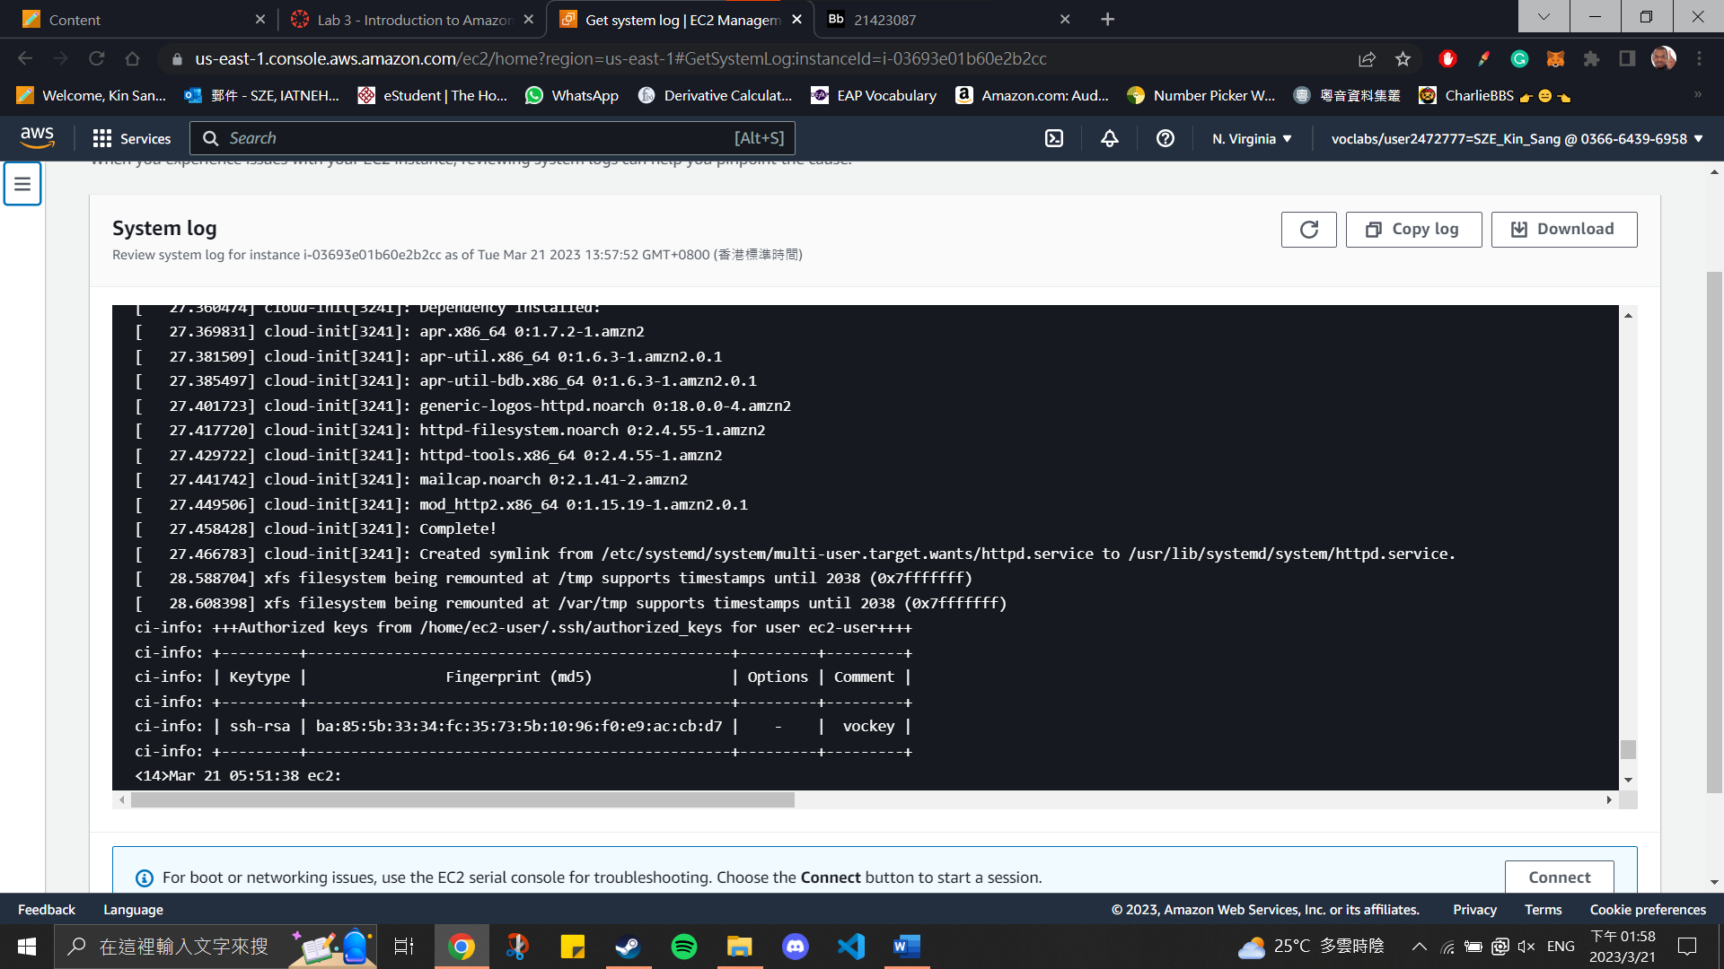

Lab report #3.2:

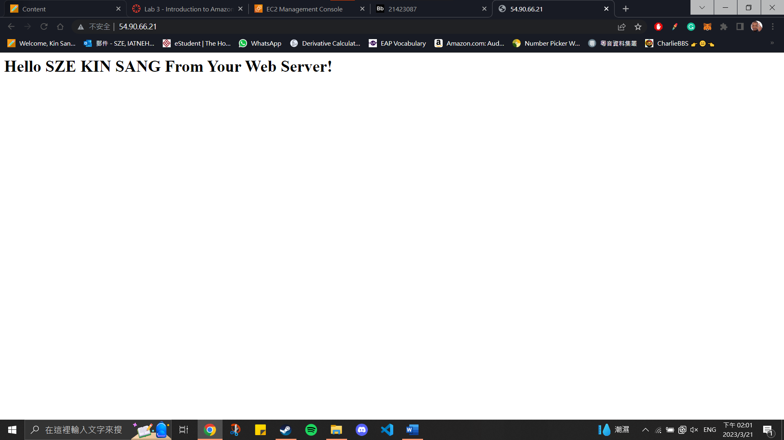

Lab report #3.3:

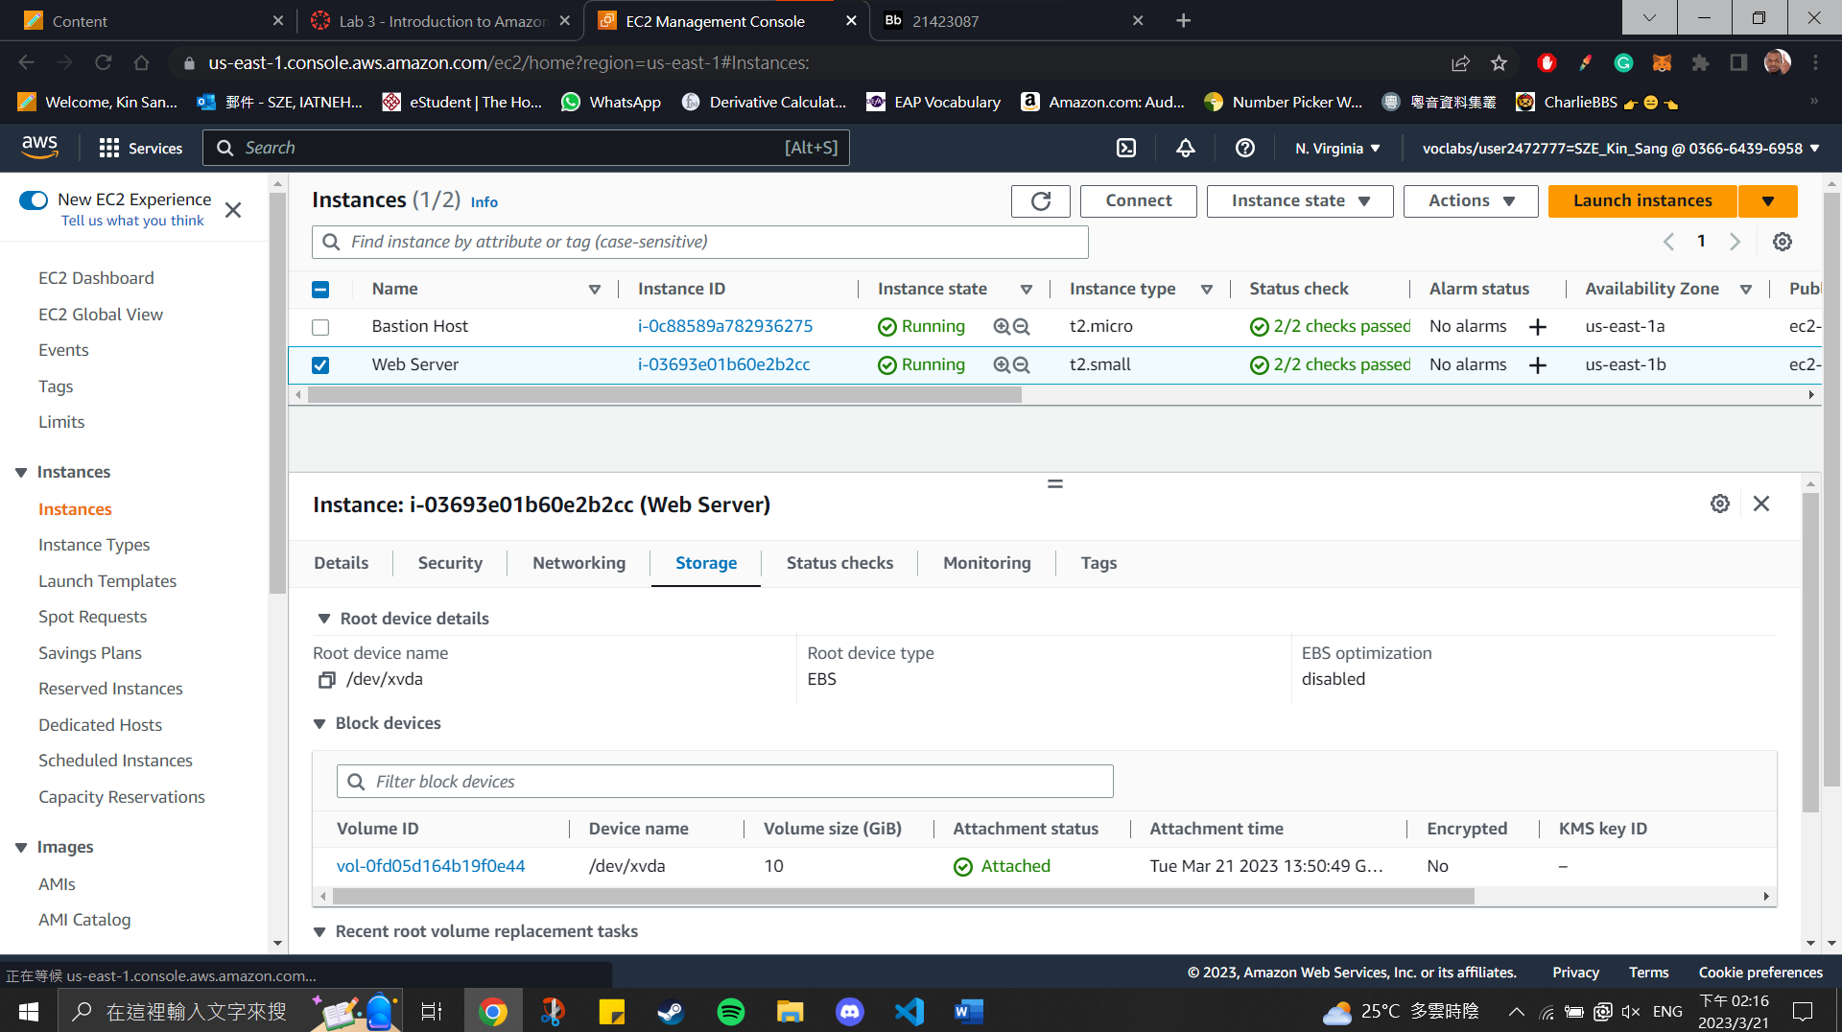

Lab report #3.4:

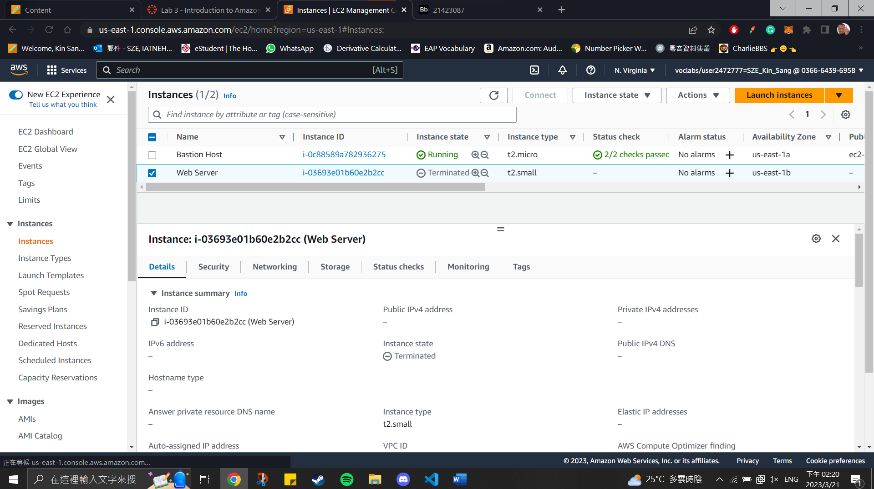

**Section 4: Working with EBS**

Lab report #4.1:

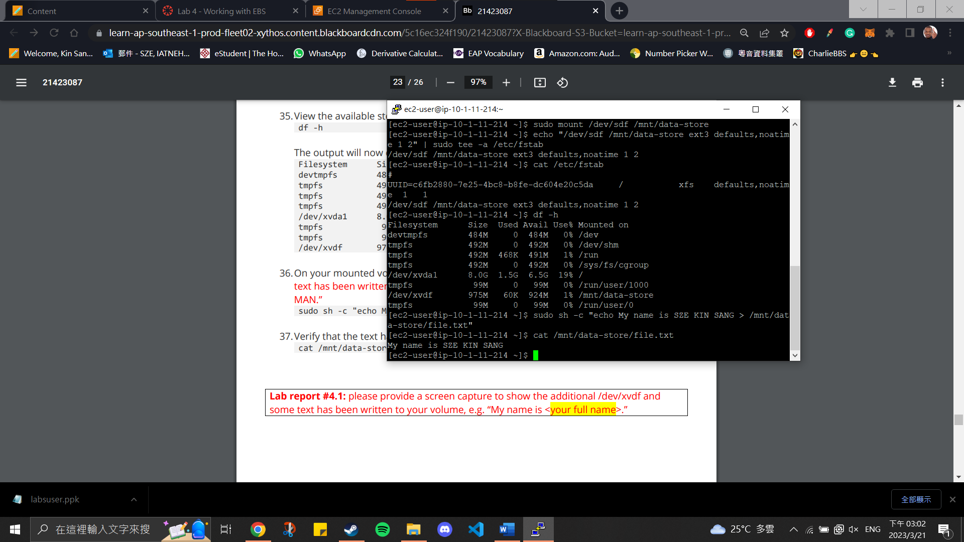

Lab report #4.2:

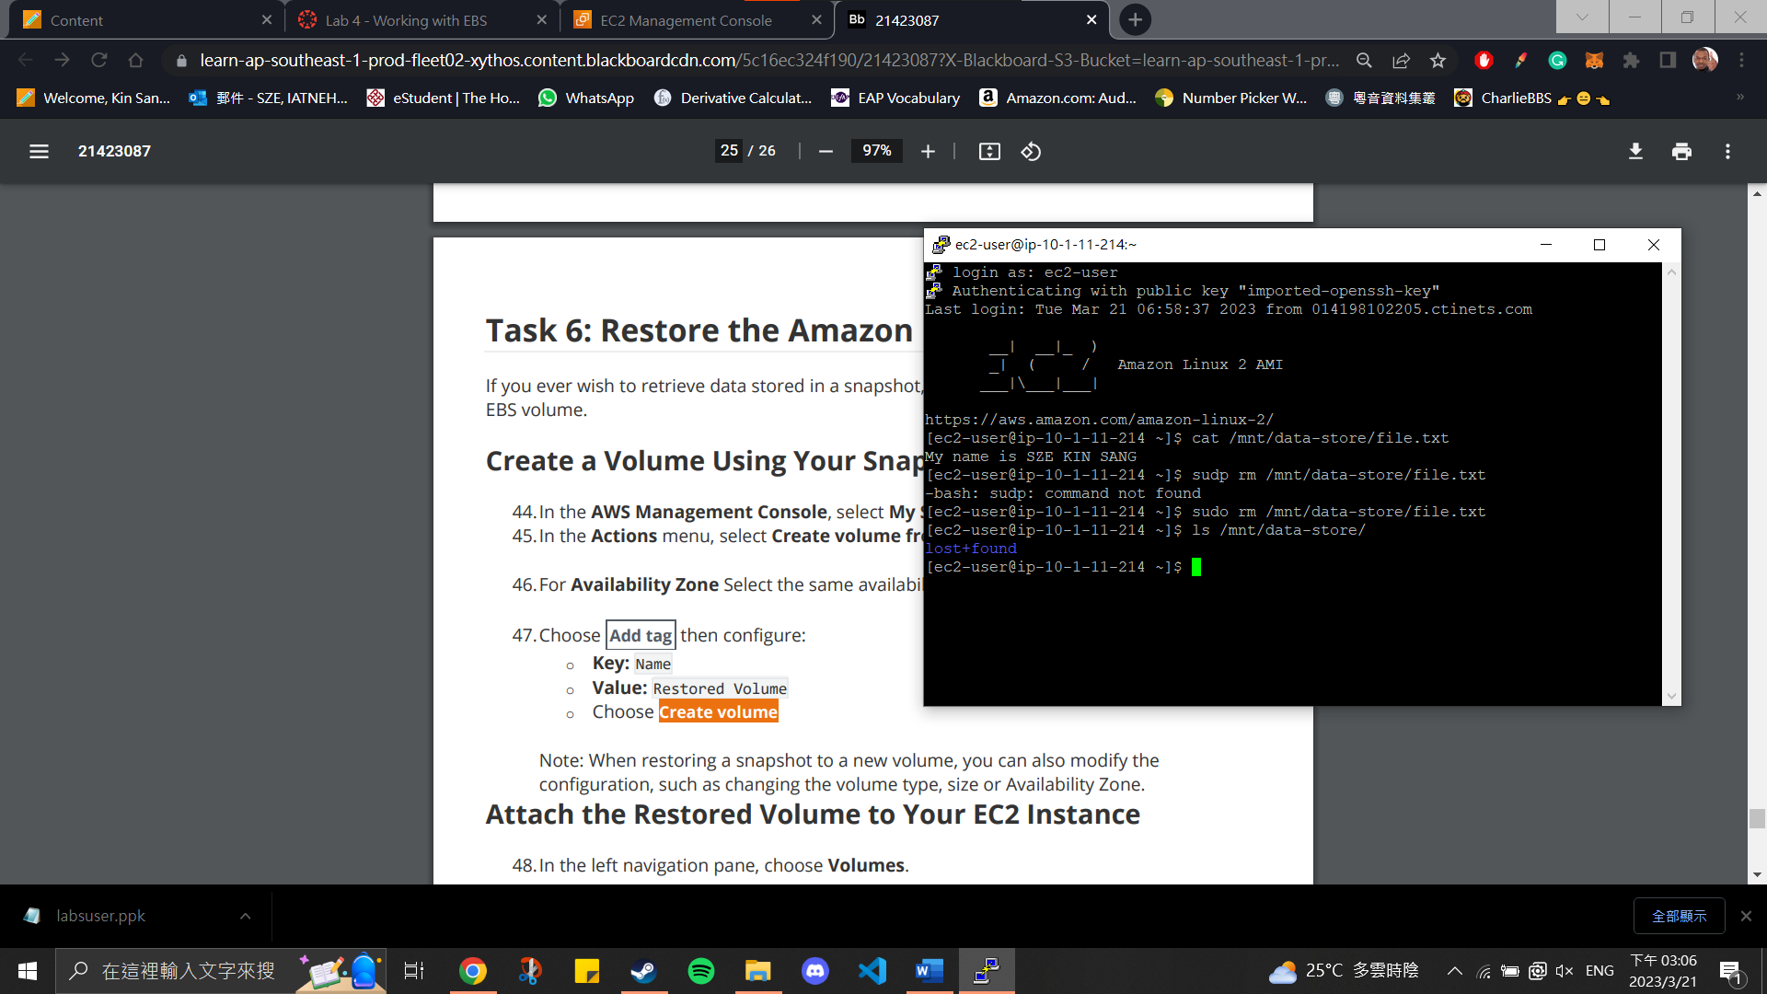

Lab report #4.3:

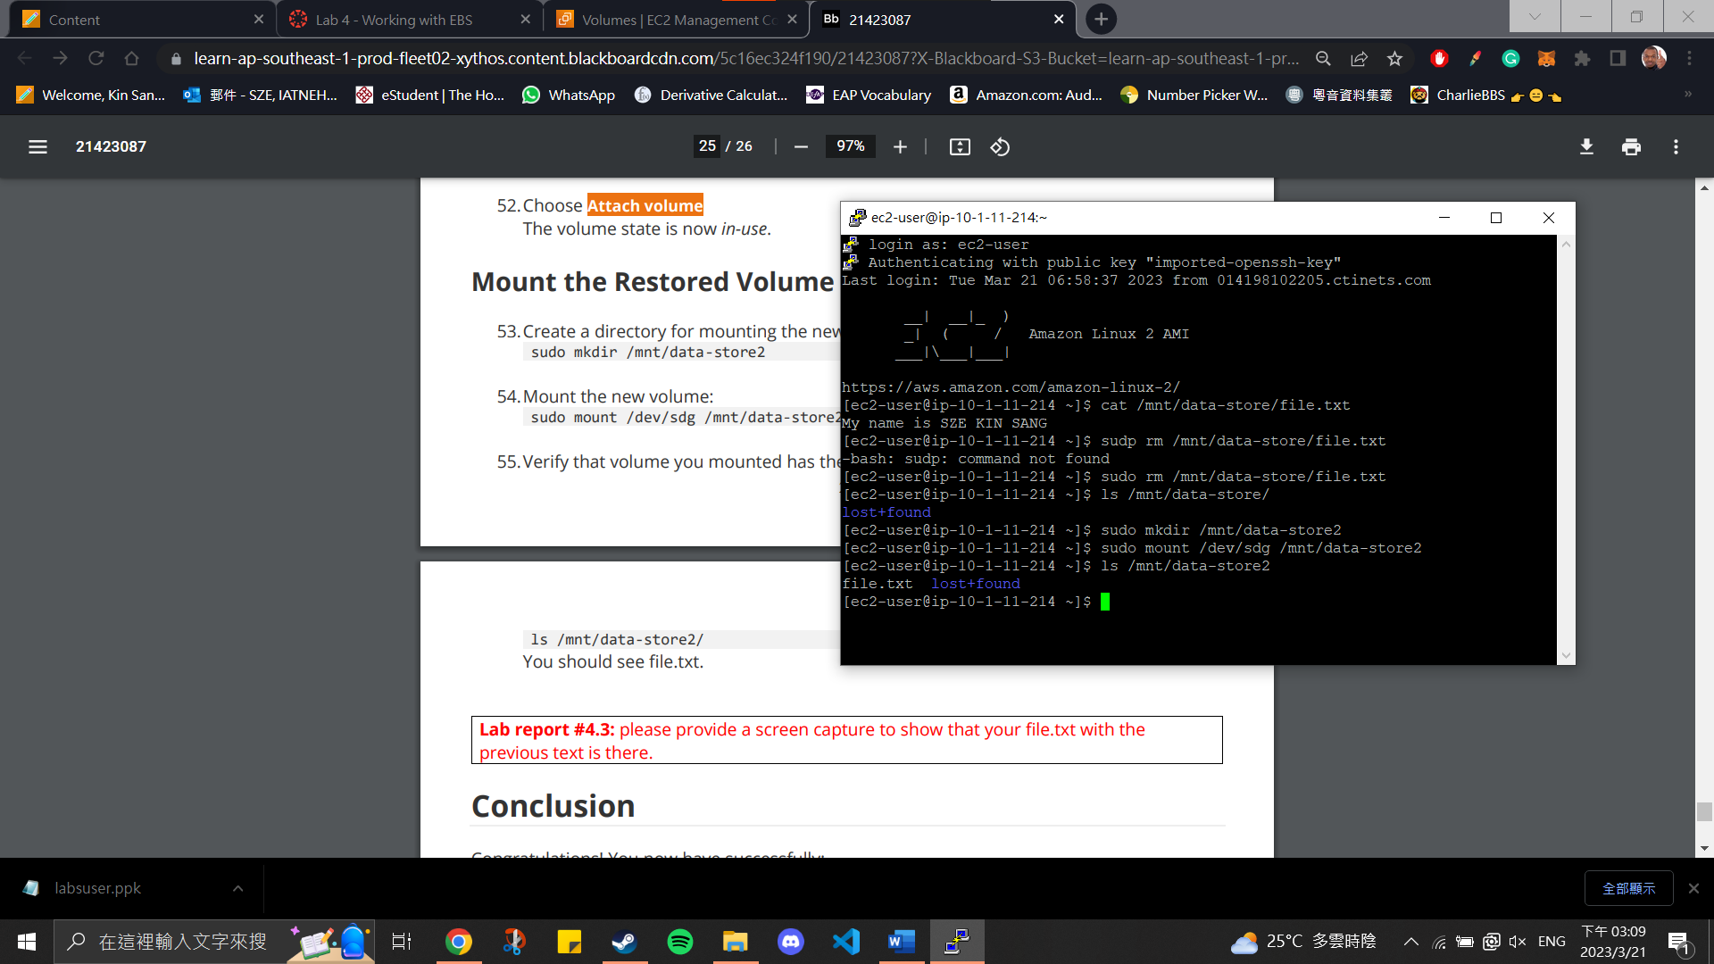

**Section 5: Build your DB Server and Interact with your DB Using an App**

Lab report #5.1:

Endpoint: lab-db.cwwe8gzpy8nr.us-east-1.rds.amazonaws.com

Lab report #5.2:

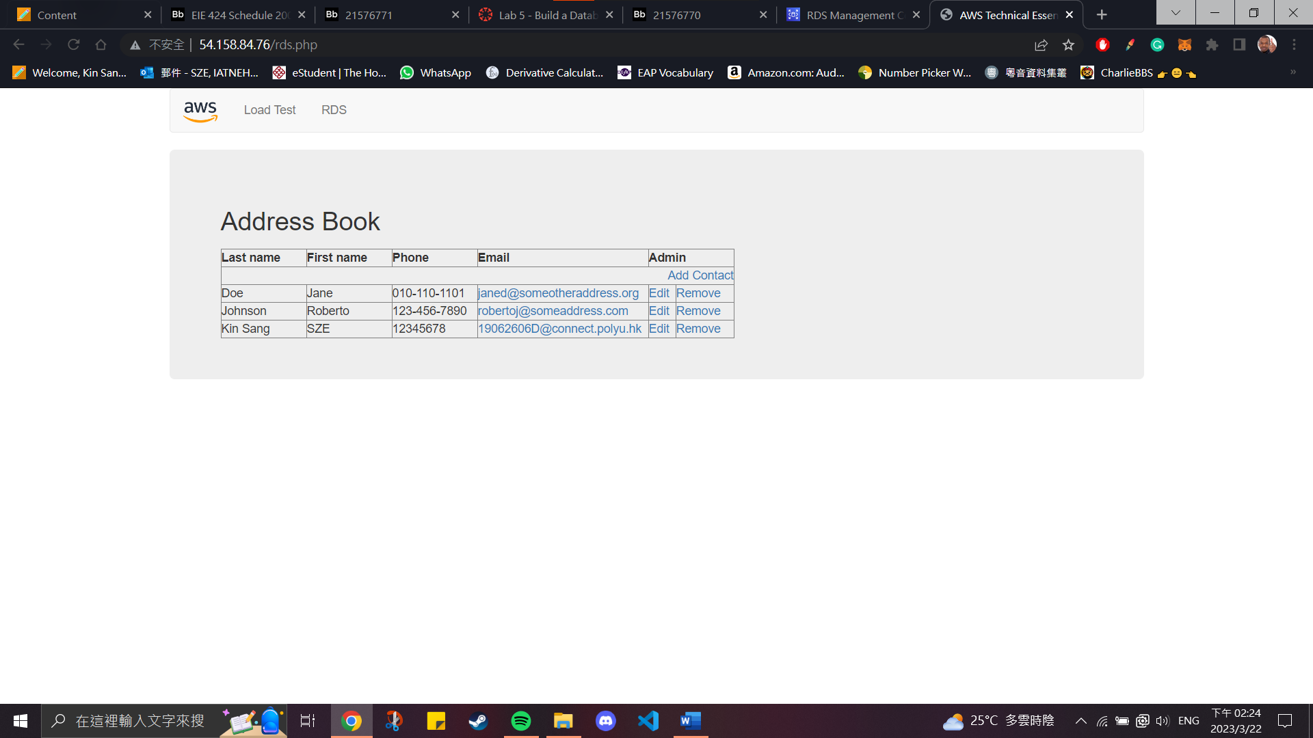

**Section 6: Scale and Load Balance your Architecture**

Lab report #6.1:

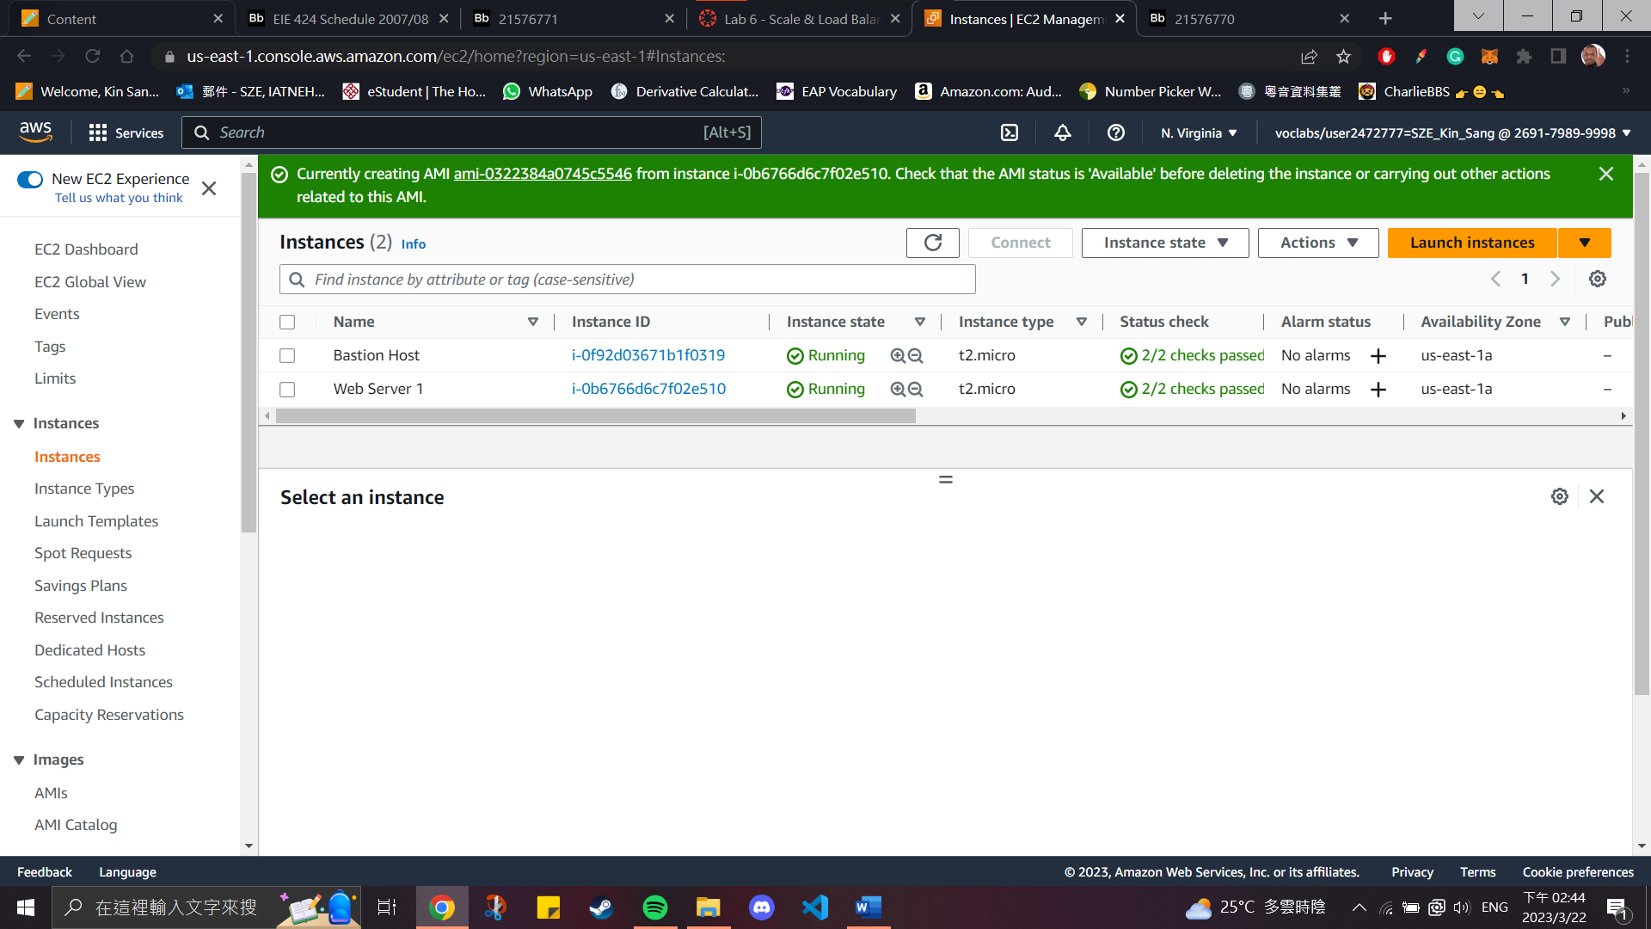

Lab report #6.2:

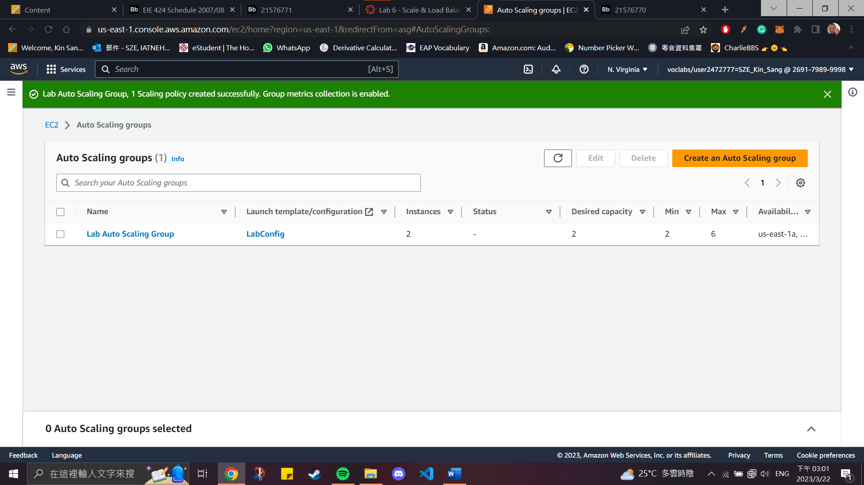

Lab report #6.3

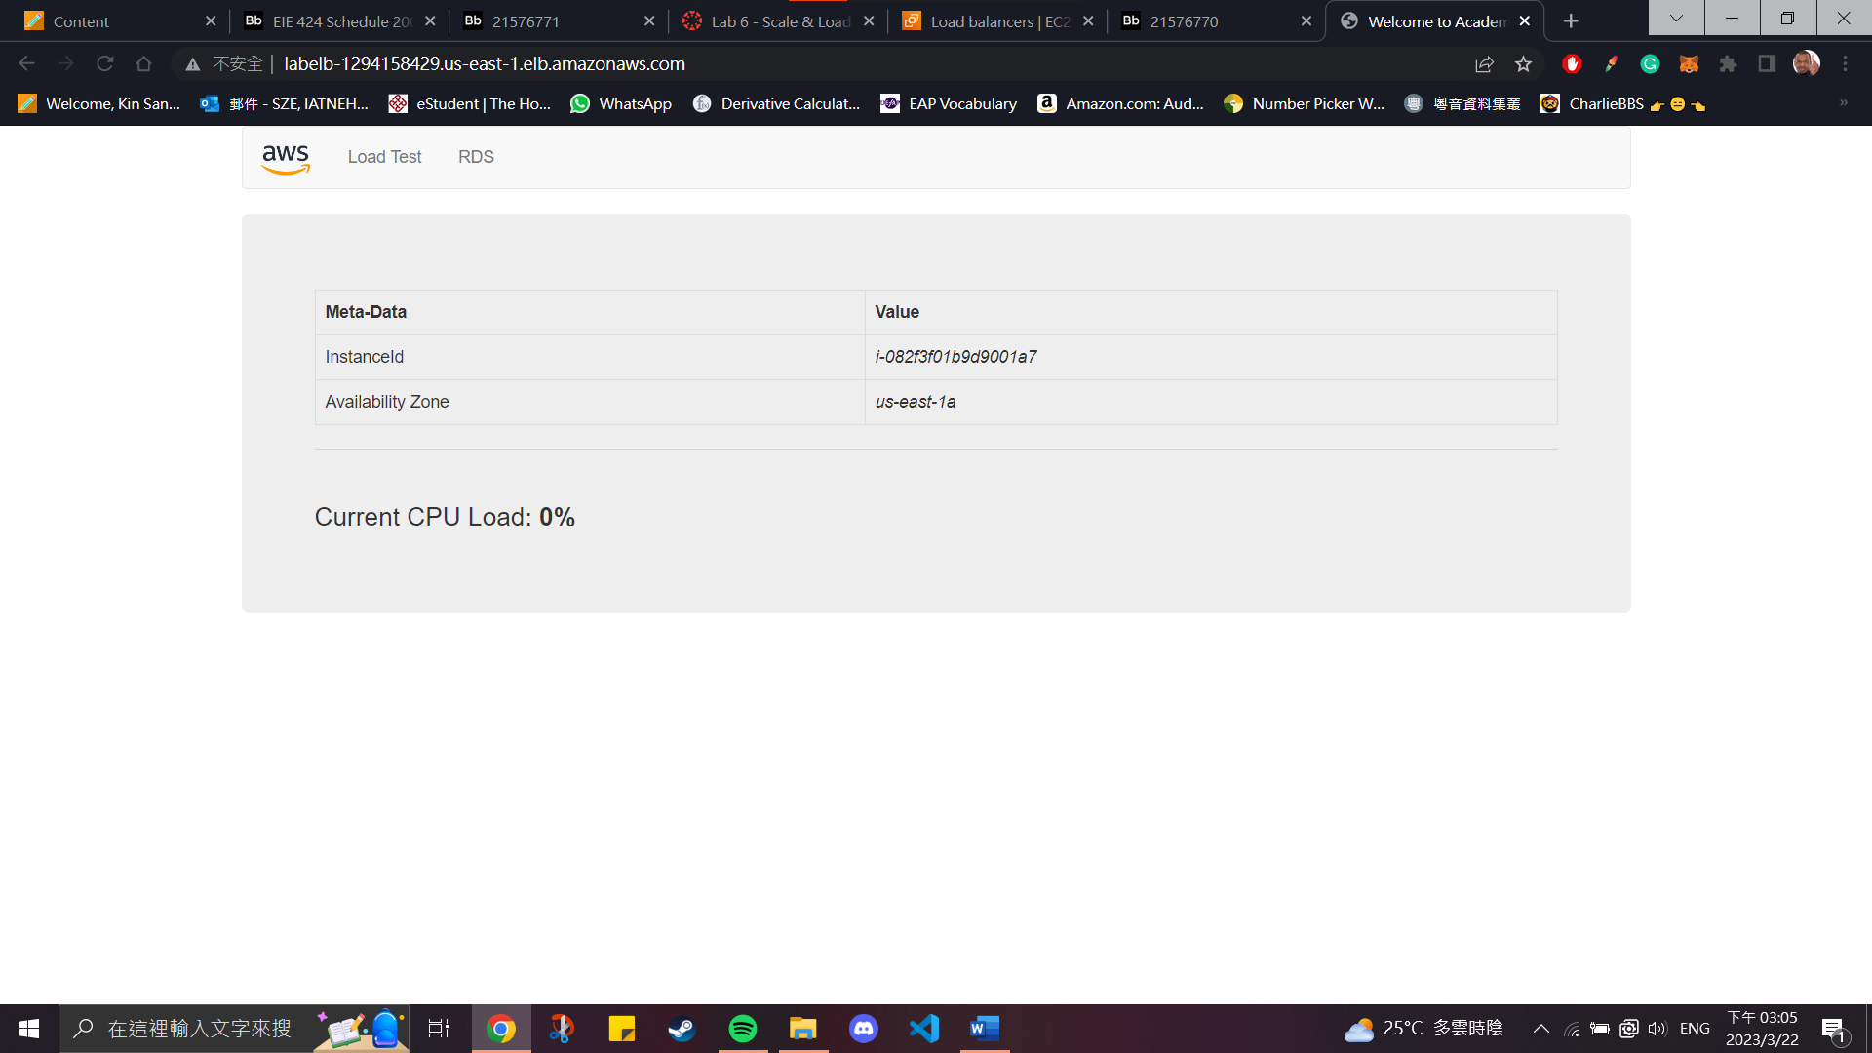

Lab report #6.4

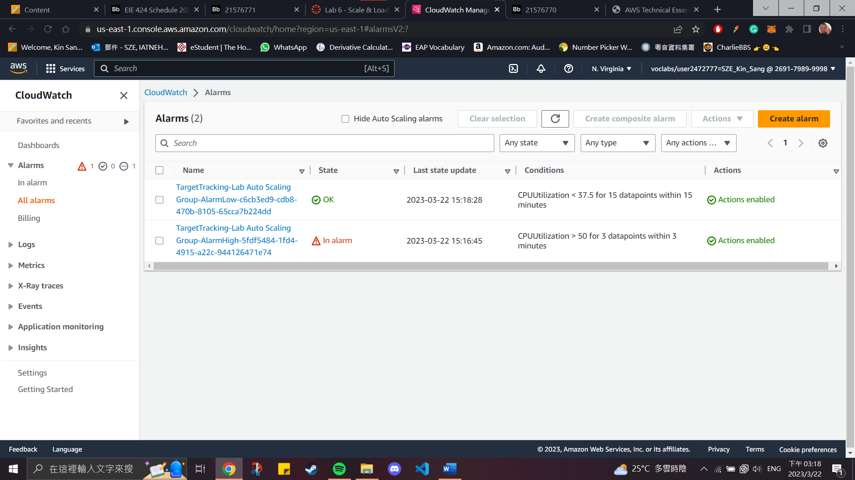

Lab report #6.4

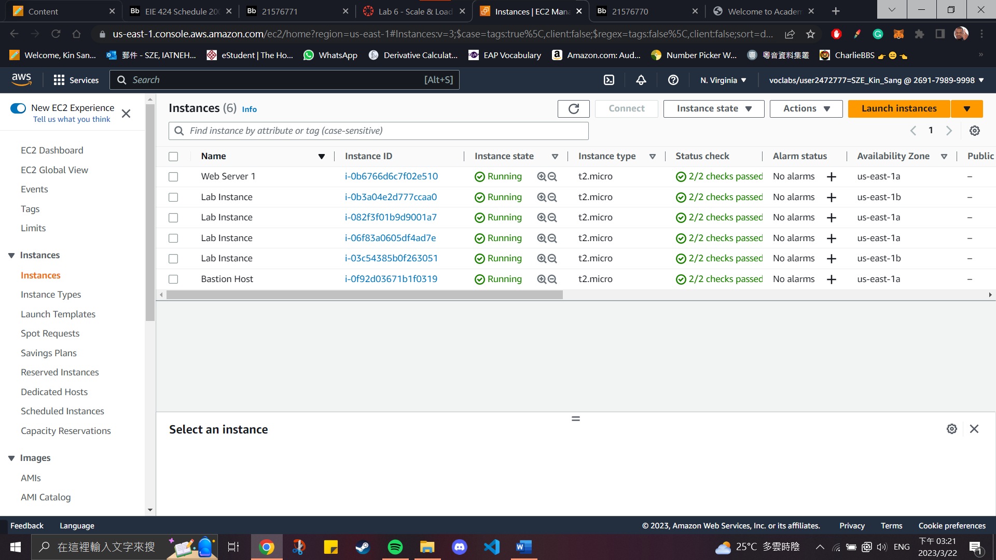

**Open-ended Question**

*Host a Static Website using AWS S3*

To host a static website on Amazon S3, we need to first create a publicly accessible bucket. Then the client can grab the index.html inside the bucket as the main page of the website.

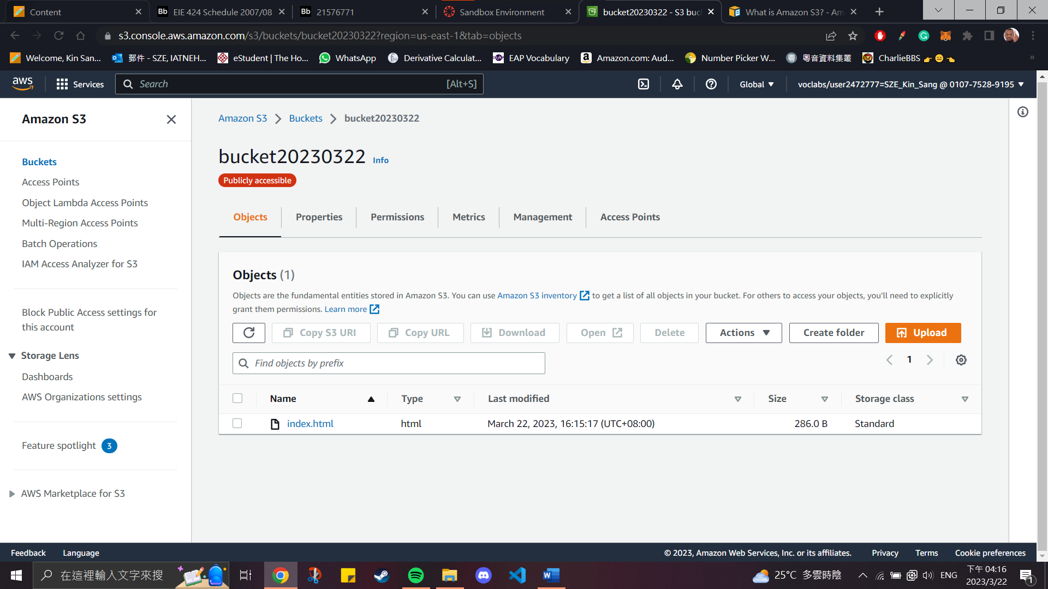

To allow public accessibility, we need to turn off the block public access setting and allow the public to read the content of the bucket with proper bucket policy. If public accessibility is blocked, access denied error will be shown.

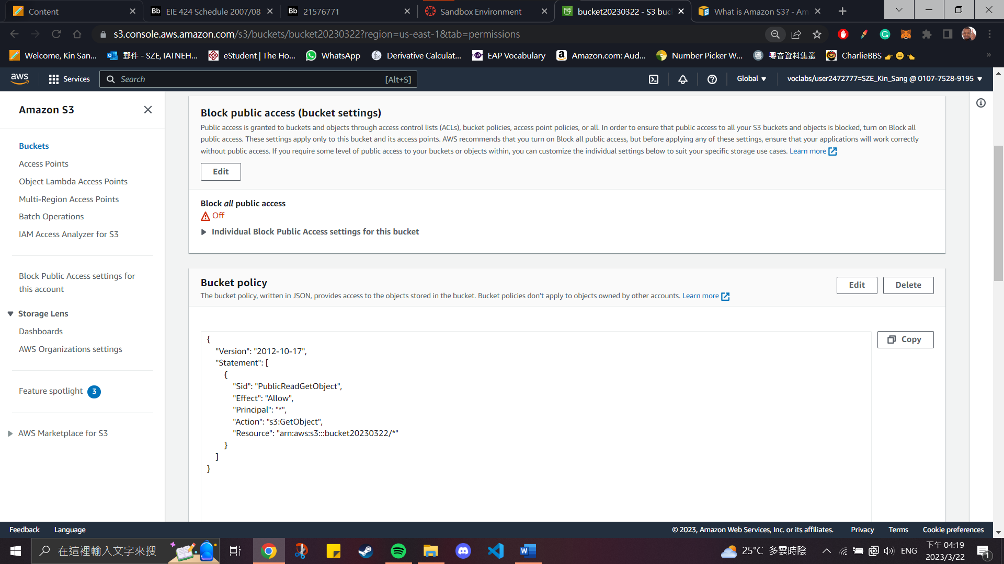 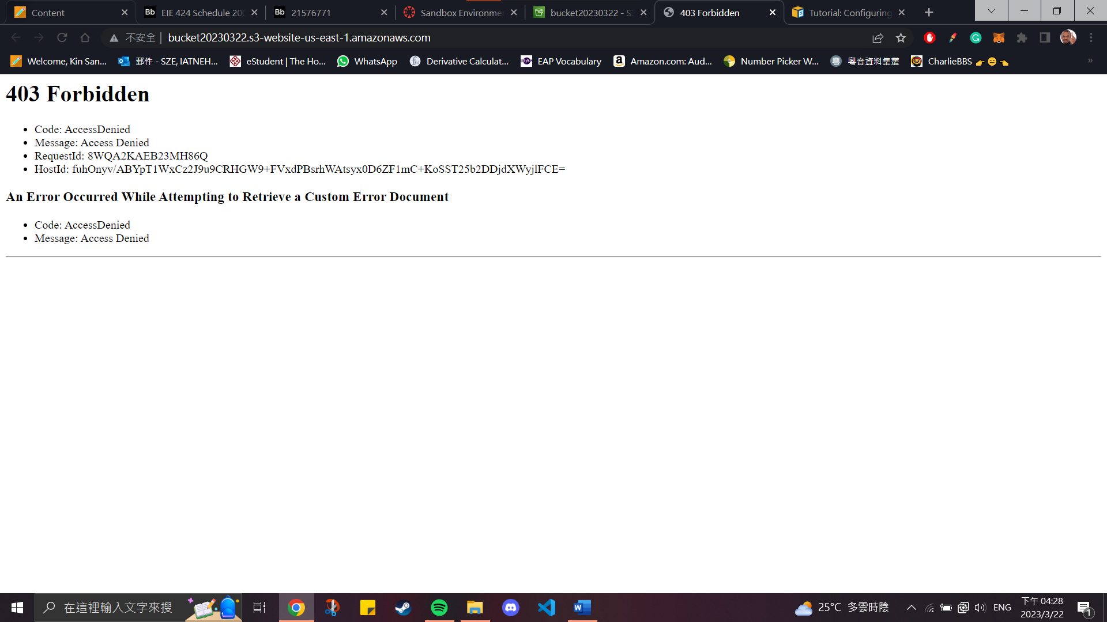

Then, turn on the static website hosting option. The index document indicates that the home page of the website. If the bucket doesn’t contain the indicated index.html, key error will be shown.

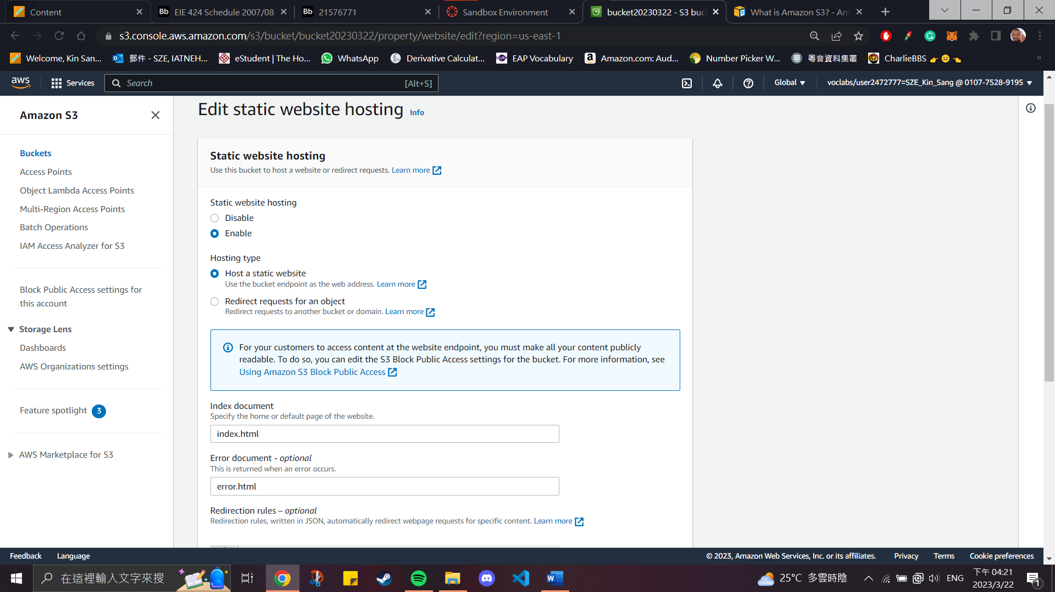

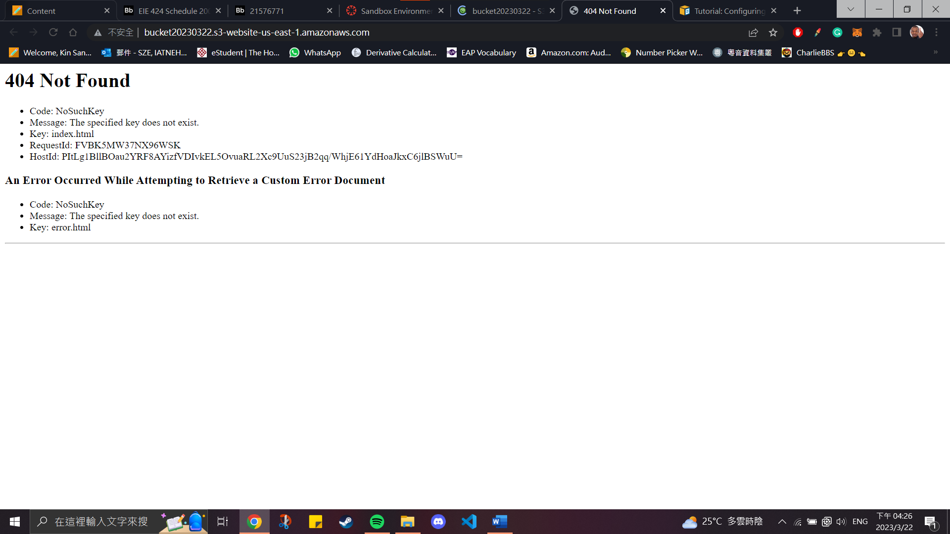

If everything is setup properly, the static website can be accessed through the public DNS address.

The DNS address: http://bucket20230322.s3-website-us-east-1.amazonaws.com

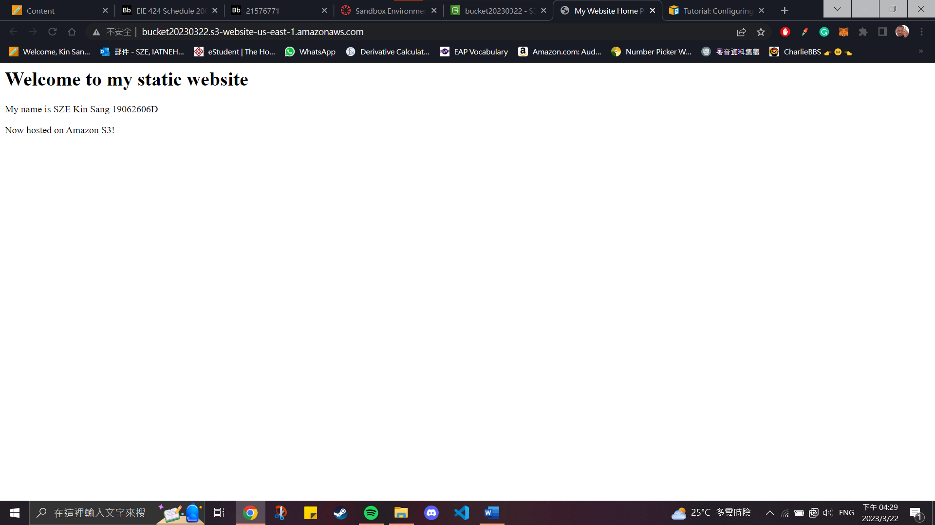

*Deploy your web application using AWS Elastic Beanstalk*

By creating a Elastic Beanstalk environment, it allows user to quickly deploy a static website without requiring to do the setting on the EC2 and S3.

To create an environment, we should follow the console’s instructions and pay attention to the match the platform with web application code.

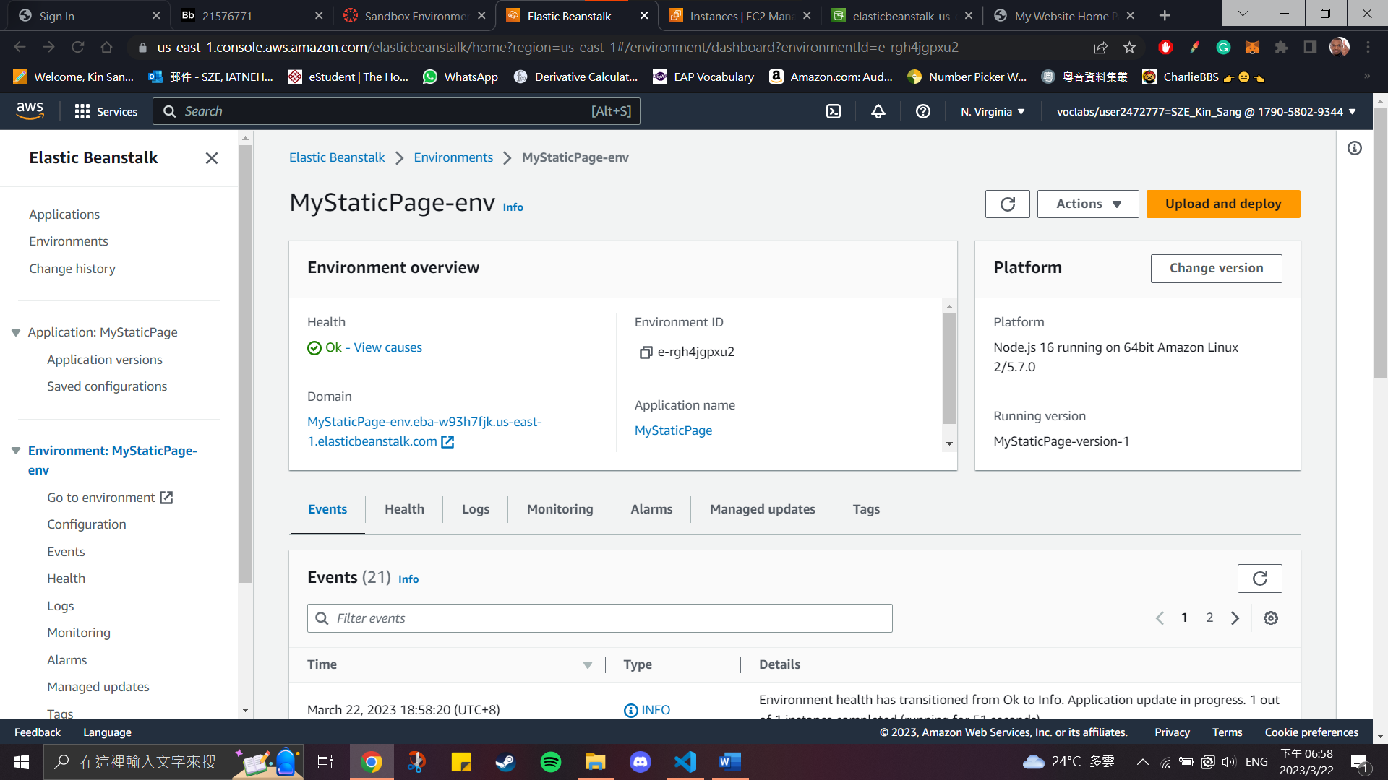

After creating the environment, the instance will also be automatically launched.

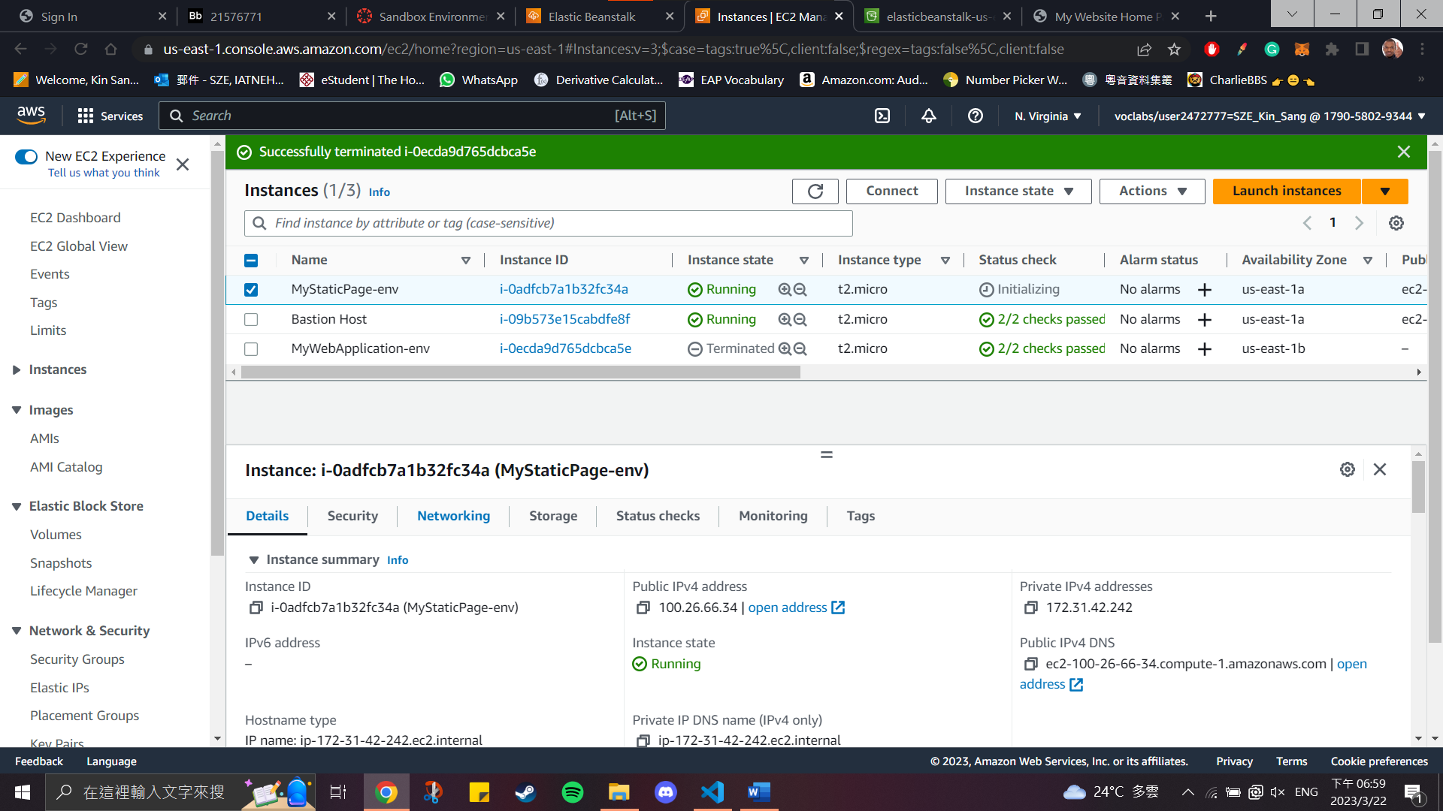

At the same time, a bucket for the environment will also be created.

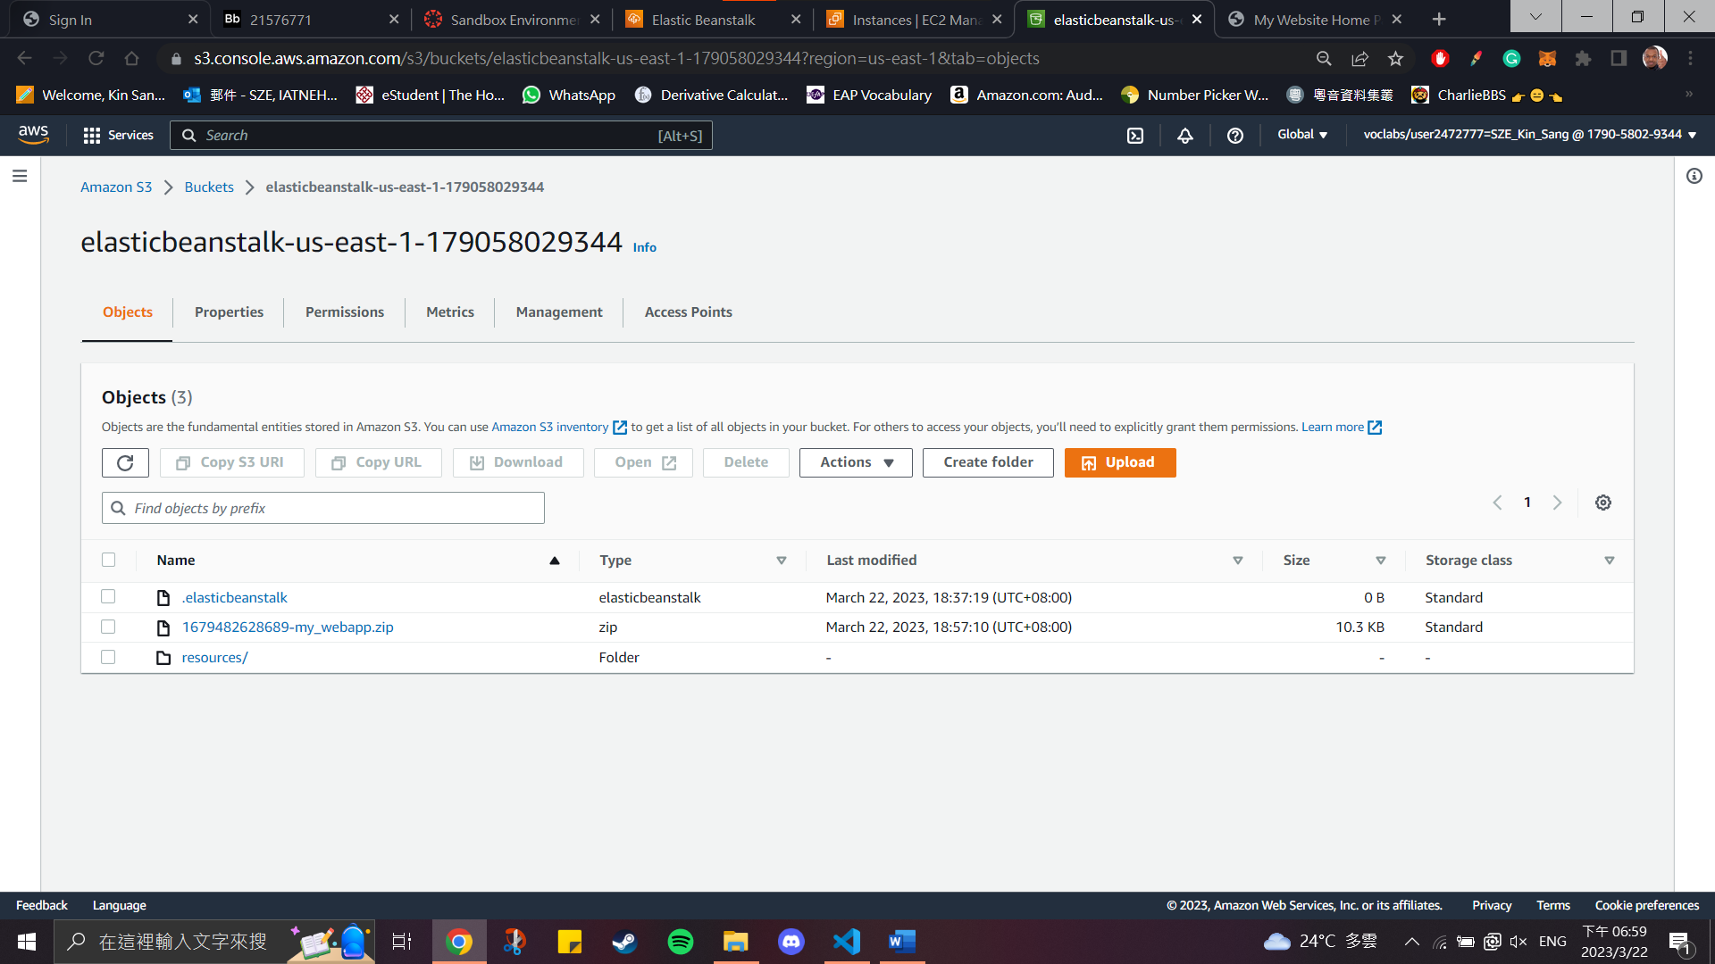

As a result, we are able to upload and deploy a simple web application. The content of the application is shown below.

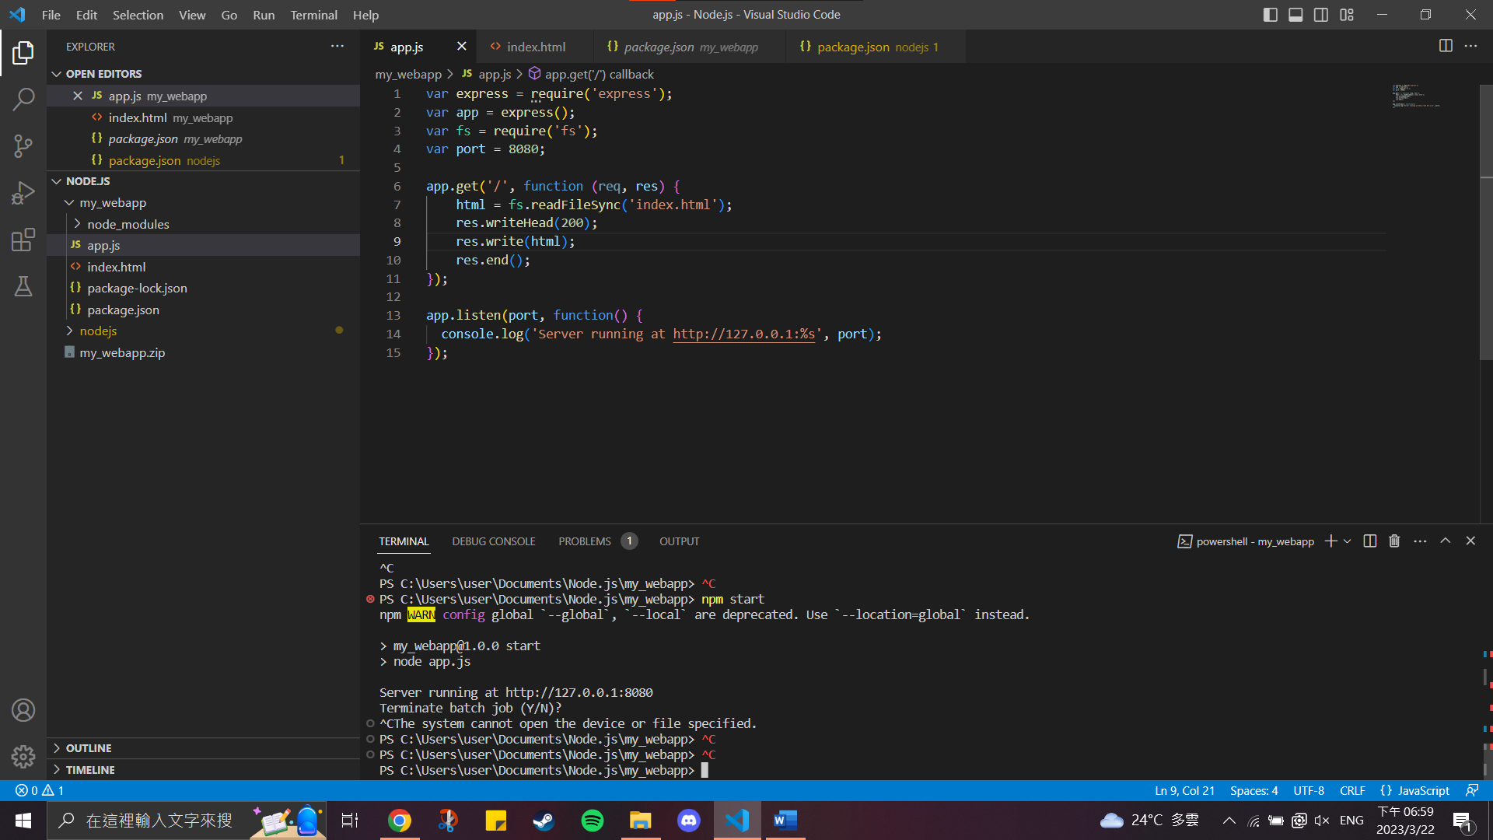

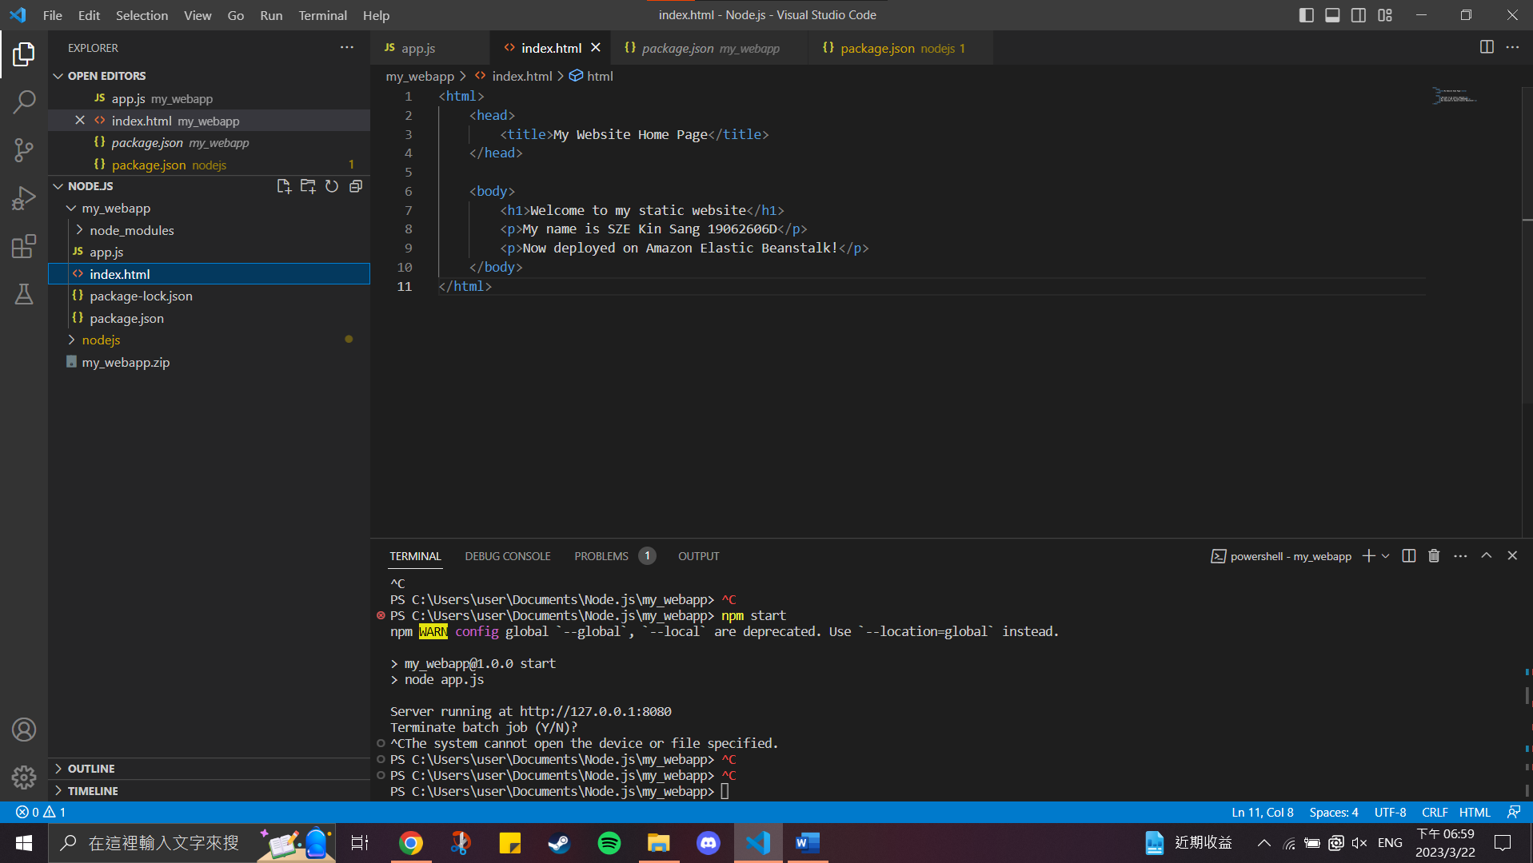

Afterwards, we can access the web application through the environment domain or instance DNS address.

Environment domain :

http://mystaticpage-env.eba-w93h7fjk.us-east-1.elasticbeanstalk.com/

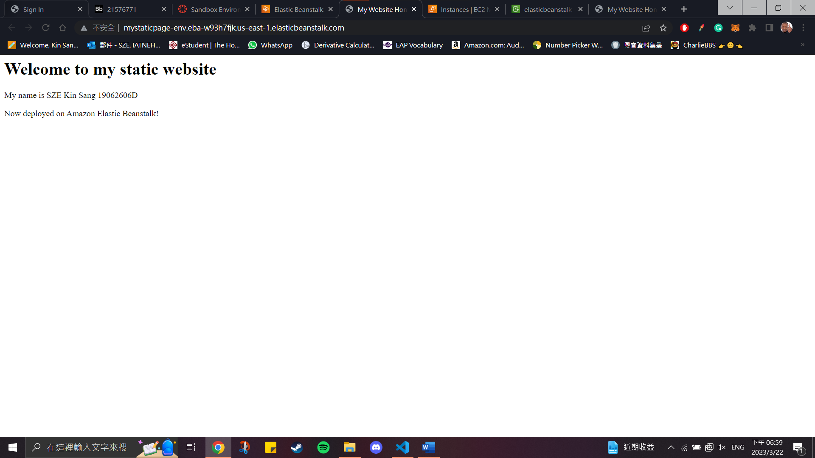

DNS address: http://ec2-100-26-66-34.compute-1.amazonaws.com/

